Architectural Review Checklist

NCI BioPortal
Release 1.0

Revision Document History
Date | Version | Description | Author
09/10/03 | 1.0 | First draft | NCICB Dedicated Support
11/07/03 | 1.0 | Final version 1.0. | NCICB Dedicated Support
05/12/04 | 2.0 | Redesign to incorporate developer answer phase followed by a systems interview phase. | NCICB Dedicated Support

Table of Contents
1. Introduction 6
1.1 Purpose 6
1.2 Guidelines for Completing the ARC 6
2. Project Details 6
2.1 General Information 6
2.1.1 Project Description 6
2.1.2 Contact Information 7
2.1.3 Major Deployment Milestones 7
2.2 Architectural Details 7
2.2.1 High level architectural description 7
2.2.2 High Level Design Diagram 7
2.2.3 Implementation language(s) 7
2.2.4 Will connections/requests to the application be session based (i.e. statefull versus stateless)? If so, is there any reason why application would not support “sticky session” load balancing? 7
2.2.5 Will the application be caching data? If so, what is being cached and how much data will be cached? 7
2.2.6 What data files will be created (if any)? How much data will be saved on an on going basis? 8
2.2.7 Will this application need a database schema(s) created on the NCICB infrastructure? If so, what is the maximum number of objects to be stored? 8
2.2.8 Are there any external/non-NCICB data sources that will be accessed by the application? 8
2.2.9 If this is a web-based application, what are the preferred virtual hosts names to be registered? 8
2.2.10 Any additional architectural details that may be of significance to the needed deployment environment. 8
2.3 Performance Requirements 8
2.3.1 Total number of users for this application? 8
2.3.2 Peak number of concurrent users? 8
2.3.3 Peak number of requests/minute? 8
2.3.4 Up time requirements? 8
2.3.5 Acceptable down time when recovering from major systems disaster? 8
2.4 NCICB Project Dependencies 8
2.5 Configuration Management Details 8
2.5.1 Version Control 8
CVS. 8
This is a new project. We envision change requests being managed by our customer (OSB). 9
2.5.2 Migration to CVS 9
Not applicable. 9
2.5.3 Users 9
2.5.4 Build Process 9
2.5.5 Other CM Needs 9
2.6 Additional Notes 9
3. System Requirements 9
3.1 Operating System 9
<<Solaris/LINUX/Windows 2000/…>> 9
3.2 Software (Technology Stack) 9
3.2.1 Web Server: 9
3.2.2 App Server: 9
3.2.3 Database Server: 10
3.2.4 Other software components: 10
3.3 Server Hardware 10
3.3.1 Server: <<type, model, …>> 10
3.3.2 Minimum processor speed: 10
3.3.3 Minimum memory: 10
3.3.4 Minimum local drive space: 10
3.4 Storage 10
3.4.1 Expected file server disk storage (in MB): 10
3.4.2 Expected database storage (in MB): 10
3.4.3 Expected ftp storage (in MB): 10
3.4.4 Expected media/image storage (in MB): 10
3.5 Load Balancing/Fault Tolerance 10
3.5.1 Does the application support load balancing? 10
3.5.2 Implement load balancing – YES/NO 10
3.6 Networking 10
3.6.1 Any application specific port assignments? 10
3.6.2 Any additional configuration? 10
3.7 Additional Notes 10
4. Proposed NCICB Deployment Environment 10
4.1 Hardware 10
4.2 Technology Stack 10
4.3 File Server 11
4.4 Database 11
4.5 Networking 11
4.6 Other Resources 11
5. Impact Assessment 11
5.1 Overview 11
5.2 Cost 11
5.3 Timeline to implement 11
5.4 Additional Notes 11
6. Acceptance 11
7. Appendix 1 - Future Systems Requirements 12
7.1 New Architecture Diagram 12
7.2 Notes on the design change 12
7.3 Hardware 12
7.3.1 Servers 12
7.3.2 Processor speed 12
7.3.3 Memory 12
7.3.4 Drive Space 12
7.4 Software (Technology Stack) 12
7.4.1 Web Server 12
7.4.2 App Server 12
7.4.3 Other components 12
7.5 Fault Tolerance (Redundancy) 12
7.5.1 Does the application support load balancing? 12
7.5.2 Implement load balancing – YES/NO 12
7.5.3 Load balancing requirements 12
7.5.4 Fault tolerance solution suggested 12
7.5.5 Additional requirements (if any) 12
7.6 Performance Enhancements 12
7.6.1 Processing Power 12
7.6.2 Memory 12
7.6.3 I/O 12
7.6.4 Other needs 12

Introduction

Purpose
The purpose of the Architectural Review Checklist (ARC) is to help identify the deployment environment (both hardware and software components) necessary for an application to execute optimally within the NCICB IT infrastructure. The ARC is considered to be a dynamic artifact for any NCICB project and should be maintained in the configuration library (i.e. CVS) for each project. For new projects, this document template will be automatically checked into the projects repository by the SCM team upon project initiation. The ARC should be reviewed on at least a quarterly basis to capture any application design changes that may effect the deployment environment necessary for optimal performance.

Guidelines for Completing the ARC
The ARC is divided into 4 main sections. The first section (Project Details) is meant to capture general information about the project. The project development team should fill out the Project Details section and return it to the systems team. The second section (Systems Requirements) is meant to capture details of specific system requirements for the project. Both the development and system teams will preferably answer the Systems Requirement section jointly. However, depending on the development teams familiarity with the NCICB infrastructure, they may choose to answer either all or parts of this section on their own. The third section (Planned Deployment Environment) specifies the proposed deployment environment for the application and is to be answered by the systems team based on the response to section 1 & 2. Finally, the last section (Impact Assessment) describes the impact (additional hardware/software costs, staffing resources…) to the existing NCICB IT infrastructure in order to support this application. Upon completion of the Deployment Environment and Impact Assessment sections, the systems team will return the ARC to the development team for final review and comments.

Project Details

General Information

Project Description
The NCI BioPortal is a web-based terminology browser which is intended to (eventually) replace the NCI Terminology Browser and the NCI Metathesarus Browser. The terminology sources exposed through the NCI BioPortal will be retrieved via LexBIG versus the proprietary Apelon DTS servers upon which the current NCI Terminology and Metathesarus Browsers are based.

Contact Information
Title | Name | Phone | Email
Project Manager | Charles Griffin | 301.496.5373 | griffinch@mail.nih.gov
Team Lead/Architect | Johnita Beasley | 301.435.6358 | beasleyj@mail.nih.gov
SCM Coordinator | Steven Hunter |  | hunterst@mail.nih.gov

Major Deployment Milestones
Milestone | Date
Planned Release to QA | 10/04/2007 (Initial)
Planned Release to Staging | 10/17/2007 (Initial)
Planned Release to Production | 10/26/2007 (Initial)

Architectural Details

High level architectural description
The NCI BioPortal architecture is based on an n-tier computing environment that assigns responsibilities to separate application layers. This fosters a loosely coupled and tightly cohesive architecture in which objects in each layer are focused on specific architectural responsibilities yet, cleanly integrate with the other layers.

High Level Design Diagram
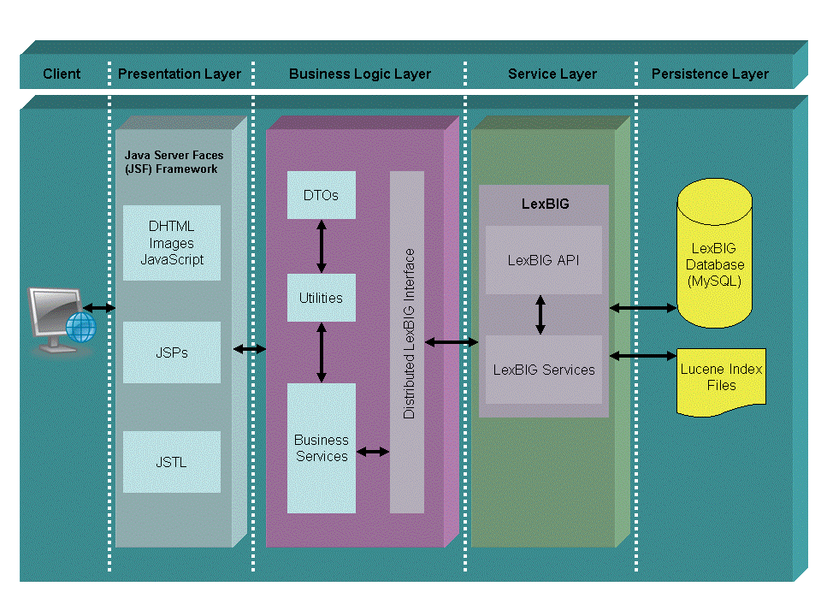

Implementation language(s)
The NCI BioPortal implementation language is Java.

Will connections/requests to the application be session based (i.e. statefull versus stateless)? If so, is there any reason why application would not support “sticky session” load balancing?
Connections/requests to the NCI BioPortal application will be session based. In this instance, there is no reason why the application would not support “sticky session” load balancing. Our server side communications will go against the Distributed LexBIG API and all requests will be stateless.

Will the application be caching data? If so, what is being cached and how much data will be cached?
Initially, we don’t foresee the need for the application to cache data.

What data files will be created (if any)? How much data will be saved on an on going basis?
The primary purpose of the NCI BioPortal is browsing terminology data. We don’t anticipate the need for the NCI BioPortal to produce data files. A secondary feature will be to submit a new term for approval. For future releases, this may result in the need for a database schema. For the initial release we may be able to handle this with email and at most a text file that would reside on the file server. This would be a relatively small file.

Will this application need a database schema(s) created on the NCICB infrastructure? If so, what is the maximum number of objects to be stored?
The NCI BioPortal will access the LexBIG MySQL database schema via the Distributed LexBIG API. For future releases, there may be a separate database schema required.

If this is a web-based application, what are the preferred virtual hosts names to be registered?
The NCI BioPortal is a web-based application. The preferred virtualhost name is bioportal.nci.nih.gov.

Any additional architectural details that may be of significance to the needed deployment environment.
The initial NCI BioPioPortal deployment may require the staging of an application accessible directory of downloadable files. This requirement may be able to be achieved through the existing FTP site for EVS terminologies.

Performance Requirements

Total number of users for this application?
Initial Estimate: 2000

Peak number of concurrent users?
Initial Estimate: 200

Peak number of requests/minute?
Initial estimate: 30

Up time requirements?
24 hours/day, 7 days/week

Acceptable down time when recovering from major systems disaster?
24 – 48 hours.

NCICB Project Dependencies
At present, the only NCICB project the NCI BioPortal has a dependency on is the Distributed LexBIG API (new as part of the EVS 4.0 Release).

Configuration Management Details
Briefly describe your current configuration management practices here.

Version Control
What version control software are you currently using, if any?

CVS.

What are your current change control practices? What procedures are in place to determine whether to implement a change request?

This is a new project. Change requests (i.e. new features, bugs) will be reviewed and evaluated by the Project/Product Management Team. If deemed appropriate the change will be addressed (following EVS Procedures) and a Change Control Request will be submitted for the identified release as planned.

Migration to CVS
Indicate whether you will require SCM support migrating your source code to the NCICB CVS repository.

Not applicable.

Users
Provide a list of all developers who require access to your repository modules.
Johnita Beasley
Kim Ong
Charles Griffin
David Yee
Steven Hunter
Tracy Safran

Build Process
Describe your build process here. For example, are you using Ant, Make, or something else?
NCI BioPortal will use Ant for its build process.

Other CM Needs
Describe any other CM needs?
None at this time.

Additional Notes

System Requirements

Operating System

<<Solaris/LINUX/Windows 2000/…>>

Software (Technology Stack)

Web Server:
Tomcat via JBoss

App Server:
Tomcat via JBoss

Database Server:
MySQL via the Distributed LexBIG API.

Other software components:
Java Server Faces (JSF)

Server Hardware

Server: <<type, model, …>>

Minimum processor speed:

Minimum memory:

Minimum local drive space:

Storage

Expected file server disk storage (in MB):

Expected database storage (in MB):

Expected ftp storage (in MB):

Expected media/image storage (in MB):

Load Balancing/Fault Tolerance

Does the application support load balancing?

Implement load balancing – YES/NO

Networking

Any application specific port assignments?

Any additional configuration?

Additional Notes

Proposed NCICB Deployment Environment

Hardware
<<dev, qa, staging, production servers to be used>>

Technology Stack
<<specific technology stack to be used>>

File Server
<<space allocation on big IP, NFS mount points, initial size allocation…>>

Database
<<database server to used, schema names to be created, initial size, maximum size…>>

Networking
<<e.g. any BigIP configuration necessary, …>>

Other Resources
<<e.g. ftp server access, media server access, …>>

Impact Assessment

Overview

Cost

Timeline to implement

Additional Notes

Acceptance
Project Lead ( ) | Project Coordinator – NCICB ( )
Systems Team | SCM Administrator

Appendix 1 - Future Systems Requirements
In this section, describe any projected future anticipated requirements for your system.

New Architecture Diagram

Notes on the design change

Hardware

Servers

Processor speed

Memory

Drive Space

Software (Technology Stack)

Web Server

App Server

Other components

Fault Tolerance (Redundancy)

Does the application support load balancing?

Implement load balancing – YES/NO

Load balancing requirements

Fault tolerance solution suggested

Additional requirements (if any)

Performance Enhancements

Processing Power

Memory

I/O

Other needs

