caBIG® Platform Specific Service Specification Template

LexEVS 6.0
Analytical Grid Services

Version 1.0
December 23, 2010

Authors | Craig Stancl, Kevin Peterson, Scott Bauer, Sridhar Dwarkanath
Editor | Craig Stancl
Reviewers | Identify all reviewers
Architecture Inception Team | Craig Stancl, Harold Solbrig, Kevin Peterson, Scott Bauer, Sridhar Dwarkanath, Traci St. Martin
DOCUMENT CHANGE HISTORY

Version Number | Date | Contributor | Description
1.0 |  | Craig Stancl, Sridhar Dwarkanath | Initial Draft

** Following section to be removed from the final document **

Legend
Type of text | Color | Font | Style
Instructions | Red | Times New Roman Size 12 pt. | Italics
Examples | Blue | Courier New Size 12 pt. | Regular
Content | Black | Times New Roman Size 12 pt. | Regular
Note:
- Red: Represents all the instruction provided to the user of the document to follow
- Blue: Represents notional examples provided for the user’s understanding
  - Example diagram are provided with a blue border
- Neither Instructions nor Examples should appear in the final specifications created
- All the text in the final specifications document should be on black only (unless highlighting is specifically needed)
Table of Contents
1 Executive Summary: 5
1.1 Service Description and Purpose 5
1.2 Scope 5
1.3 Platform Details 6
1.4 Referenced Standards 7
2 Conformance to Platform Independent Model 8
2.1 Conformance Profile 8
2.2 Dynamic Interactions 9
3 Platform Specific Model 11
3.1 Overview 11
3.2 Assumptions and Dependencies 11
3.3 Service Interface 12
3.3.1 Interface Model 13
3.3.2 Operations Details for <Interface Name> 16
3.3.3 Operations Details for LexBIGServiceGrid 17
3.3.4 Operations Details for CodedNodeGraphGrid 27
3.3.5 Operations Details for CodedNodeSetGrid 38
3.3.6 Operations Details for LexBIGServiceMetadataGrid 47
3.3.7 Operations Details for HistoryServiceGrid 50
3.4 Message Information Model 57
3.4.1 Information Model 57
3.4.2 Information Model Description 57
3.5 Service Interactions 58
3.5.1 Actors 58
3.5.2 Interaction Details 58
3.6 Implementation Considerations 59
3.6.1 Security 59
3.6.2 Auditing 62
3.6.3 Privacy 62
3.6.4 Error Handling 62
3.7 Deployment Details 64
3.8 Constraints 64
4 Recommendations for Conformance and Compliance 65
4.1 Conformance Assertions 65
5 Appendix A - Relevant Standards 66
6 Appendix B - Glossary 67

Executive Summary:

Service Description and Purpose
Provide the overall description of the service and its intended purpose.
LexEVS 6.0 represents the next generation of NCI Enterprise Vocabulary Services. LexEVS is a mechanism for the standard storage of controlled vocabularies and ontologies defining a flexible format for accurately representing a wide variety of vocabularies and other lexically-based resources in several different server storage repositories as well as a XML format.

LexEVS provides a powerful and robust API and tool suite which permits access to controlled vocabulary content represented in the LexEVS model. This allows terminologies from a wide variety of resources such as RRF, OWL, and OBO to be represented and loaded to a single data base management system and accessed with a common set of tools and interfaces.

LexEVS is based off the LexGRID database schema and LexBIG API objects, where LexGRID defines how the terminologies are structured in the database and LexBIG defines how the terminology service looks as objects to the user. LexEVS provides optimizing query code that retrieves LexBIG objects, allows the user to tailor calls to the terminology service in such a way that a discrete set of values is returned increasing utility and interoperability.

One of the requirements of LexEVS 6.0 is to align the LexEVS Analytical Grid Services component operations - including Search and Query Operations for Code Systems and Associations but excluding other LexEVS capabilities for querying and loading Value Sets, Concept Domains and Usage Contexts – to international efforts at developing common terminology service interfaces, specifically, the Health Level Seven (HL7) Common Terminology Services – Release 2 (CTS 2) standard.

NOTE: For the purpose of this document, the terms “Code System” and “Coding Scheme” are synonymous.

Scope
Describe the overall scope of the service. Define all the functionality that this particular implementation of the service provides.
The scope of this PSM is constrained to the Analytical Grid Services components for LexEVS 6.0. Analytical Grid Services are those interfaces that are exposed on the Grid, and include the LexBIG domains of:
- LexBIGService – service identification interfaces
- CodedNodeGraph – A virtual graph where the edges represent associations and the nodes represent concept codes
- CodedNodeSet – A coded node set represents a flat list of coded entries
- HistoryService – Service reference to the history API servicing the given coding scheme
- LexBIGServiceMetadata – Interface to perform system-wide query over optionally loaded metadata for loaded code systems and providers
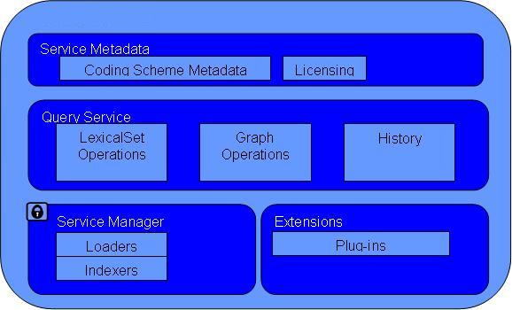
These service interfaces provide query and filtering support to the core LexBIGService interface, allowing code system content to be queried and grouped according to the different attributes and properties of code system content.
There are however, components of LexEVS that are purposely excluded from the Analytical Grid Services, such as terminology authoring and administration, value domain query and concept domain query. This section outlines the scope of LexEVS PSM with respect to the scope of the Analytical Grid Services.

Platform Details
Provide the implementation platform selected for the service and also provide the rationale behind choosing it. Examples of Service Implementation can be Java EJB Service, Web Service, RESTful Service, Grid(caGrid) Service, etc.
LexEVS 6.0 Analytical Grid Services are built as a caGrid based service. Each of the defined grid analytical grid service operations (as defined later in the document) are viewable by the caGrid Portal (http://cagrid-portal.nci.nih.gov).

In the grid services environment, the client application makes calls the grid services interfaces which in turn call the distributed LexEVS API to access content in LexEVS. LexEVS for Analytical Grid Services consists of client system, caGrid Host Server, Distributed LexEVS server and database server. The client system is responsible for making calls to access controlled terminology content from the caGrid Host Server. The caGrid Host Server is responsible for routing information both to and from the client system from the LexEVS server. The LexEVS server is responsible for serving up structured terminology content represented in the LexGrid enabled repository (database server). Lastly, the database server houses the code systems available on LexEVS.
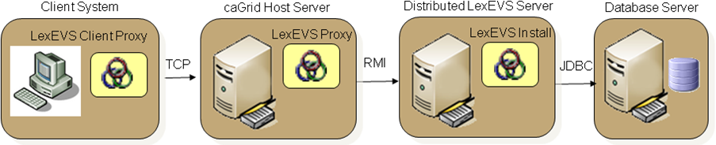

Referenced Standards
Provide references to the standards as well as technical standards that service is using.
E.g.
Standards such as - HL7V3, BRIDG2.1, ISO 21090 Data types
Listed are references to the standards and technical standards that the LexEVS Analytical Grid Service is using.
Domain Standards | Description
HL7 CTS 2 | HL7’s Common Terminology Services 2 (CTS 2) specification specifies functional model (CIM) outlining HL7’s consensus requirement for terminology services.  For the LexEVS Analytical Grid Services PSM, only the terminology and association query components of HL7 CTS 2 is considered to be in scope.  LexEVS will ultimately implement much of the CTS 2 functionality, and as such, early identification of potential points of alignment is necessary.
ISO 21090 Health Informatics – Harmonized data types for information interchange | ISO 21090 data types provide a harmonized set of data type definitions for representing and exchanging healthcare related information.  LexEVS 6.0 will interchange information using the 21090 data type specifications

Technology Standards such as SOAP 1.1, Http, Https, SAML
Technology Standards | Description
SOAP 1.1 | Simple Object Access Protocol ver 1.1 is used to interact with the service

Conformance to Platform Independent Model
This section provides details on how this Platform Specific Model and Service Specification conforms to the Platform Independent Model and Service Specification (PIMSS).
LexEVS 6.0 Analytical Grid Services PSM conforms to the corresponding PIM.
Platform Independent Model Name and Service Specification | Platform Independent Model and Service Specification Version | Description & Link to the Platform Independent Model and Service Specification
LexEVS 6.0 Platform Independent Model and Service Specification | 1.5 | https://wiki.nci.nih.gov/display/EVS/LexEVS+6.0+ECCF+Artifacts

Conformance Profile
This includes the Functional profiles and Semantic profile from the Platform Independent Model and Service Specification that this Platform Specific Model and Service Specification implements.
This conformance profile defines the query capabilities for LexEVS coding scheme and service related data for LexEVS Analytical Grid Services. This profile is invoked when LexEVS Analytical Grid Services are called to query either service specific information or terminology content and return that content in ISO 21090 data types.

Conformance Profile No. | QS-CP2
Conformance Profile Name | LexEVS 21090 Full Query Conformance Profile
Functional Profiles
  Functional Profile No. | Functional Profile Name
  QS-PF1 | QS Service Query
  QS-PF2 | QS Content Query
Semantic Profiles
  Semantic Profile No. | Semantic Profile Name
  QS-SP1 | CTS 2 Semantic Profile

Dynamic Interactions
Describe in details about any platform specific interactions which are relevant to the technology used. These interactions are on top of the business interactions which are specified in PIMSS.
Eg. Login Handshake Interaction or Obtaining Connection Interactions between the client application and the service. If necessary provide a UML Diagram
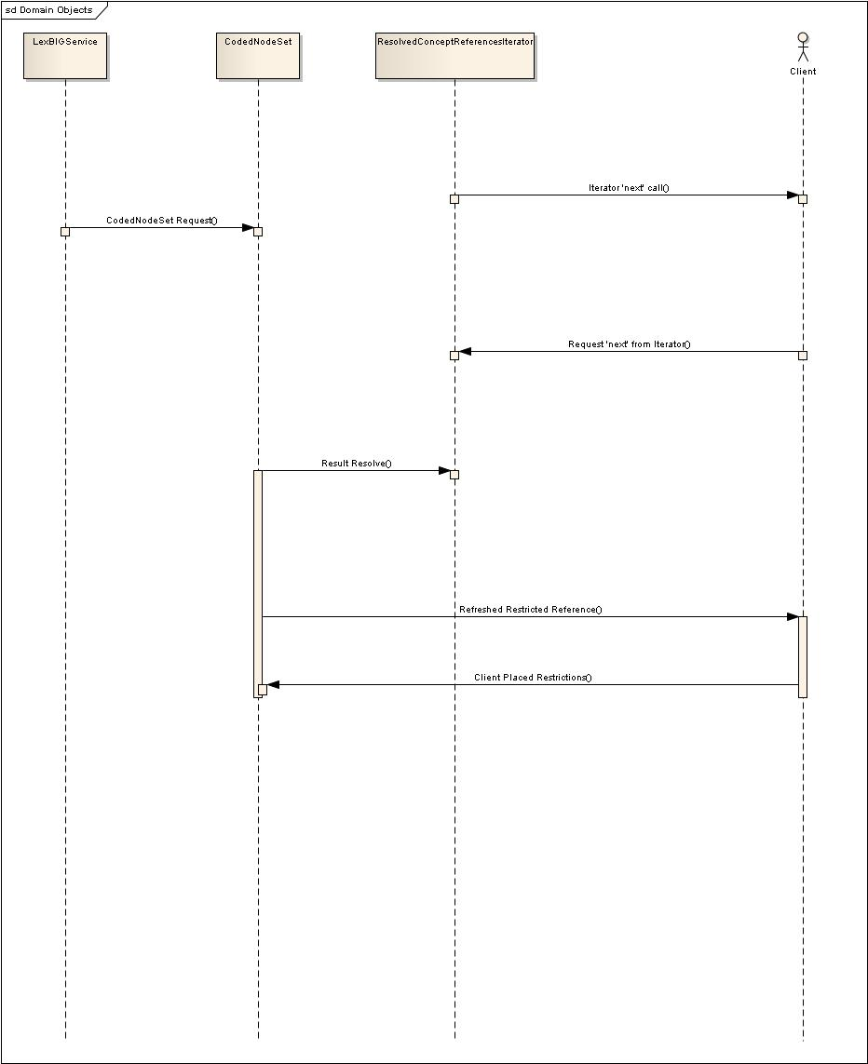

Platform Specific Model

Overview
Provide Technical overview of the platform. This includes the Domain Model and includes technology stack. This information can be a reference to a separate document if a number of services comply with the same platform.
E.g.
Domain Model
All COPPA services comply to a given implementation model of BRIDG, HL7V3, ISO 21090 data types

Domain Model | Description
NCI’s Implementation of ISO 21090 Data types | The service specifications will be based on NCI’s restricted implementation of ISO 21090 data types

Technology Stack
Specify what technology stack is used to access the service. Only interface-specific technologies should be described here.
Technology | Affects
Globus Toolkit 4.0.3 | Globus Toolkit is used to develop this grid service.
JBoss 4.0.5 | JBoss server will be used to deploy this grid service.

Assumptions and Dependencies
This section enumerates any assumptions made in this specification as well as any dependencies.
Assumptions can include deployment environment constraints such as network connectivity, lack of firewalls etc.
Assumptions | Affects
LexEVS 6.0 Analytical Grid Service will be deployed in its individual container | A new separate JBoss container needs to be procured for each of the analytical grid service installations
LexEVS 6.0 Analytical Grid Service will be deployed outside the NCI firewall. | Institutional Network team needs to ensure this is possible.

Dependencies can include external components such as the caGrid Production environment, other services. This section can include both business as well as technical dependencies
Dependency | Description
caGrid Production Environment | LexEVS 6.0 Analytical Grid Service relies on caGrid Production environment for advertisement and discovery

Service Interface
The LexEVS 6.0 Analytical Grid services are implemented as a Java API. The following link to the service UML model shows the main Java interfaces.
Links to: UML

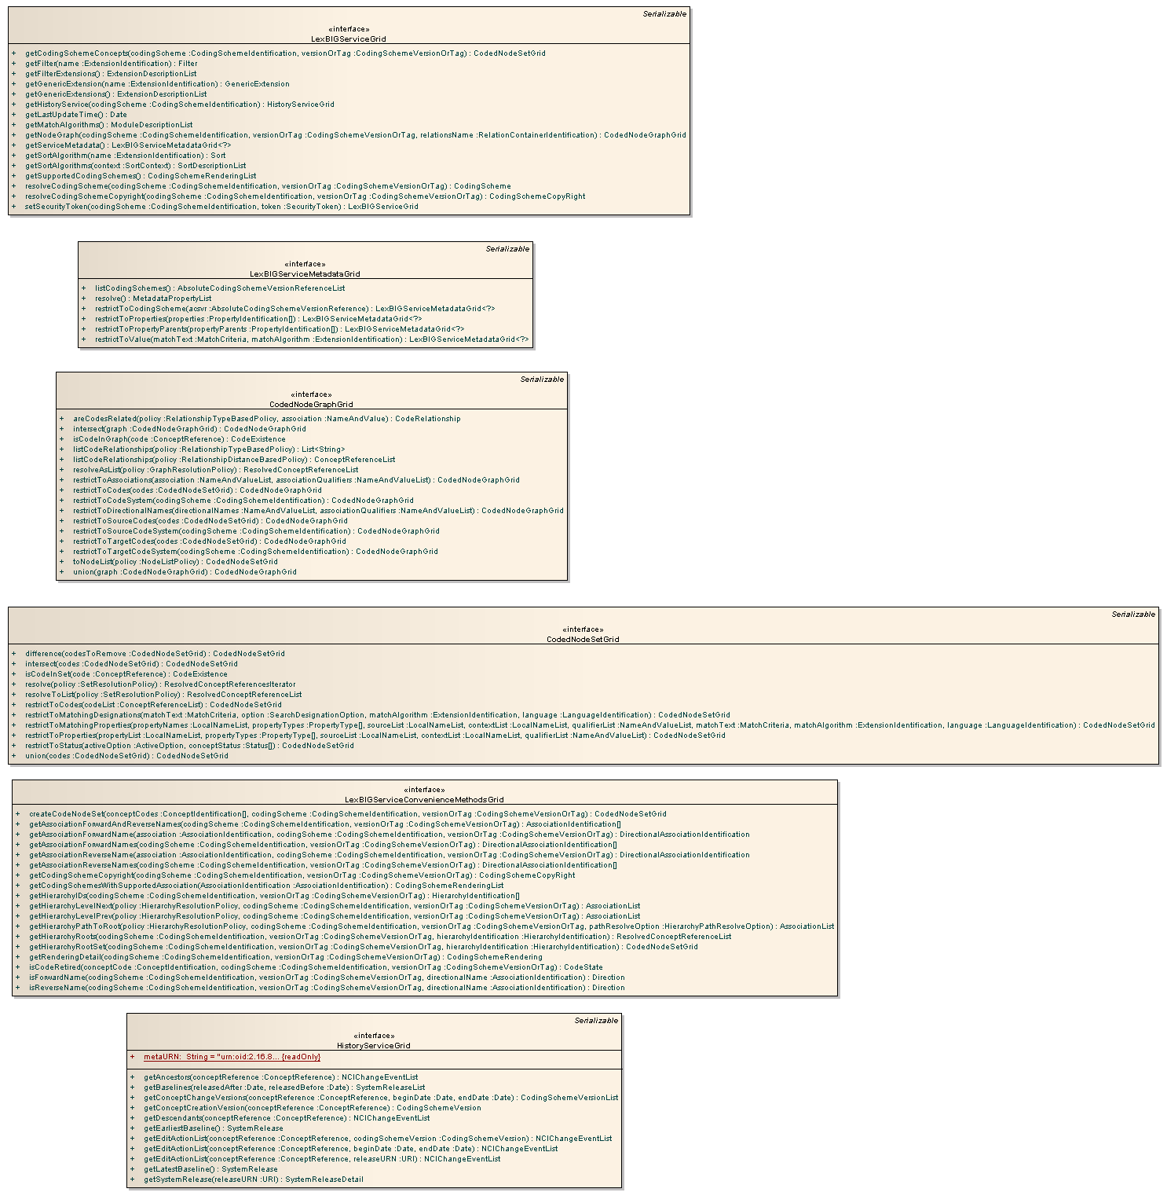

Interface Model

Implemented Interface No | Supported Interface Name | Interface Description | Link
LE_I_01 | LexBIGServiceGrid | This interface represents the core interface to a LexBIG service. | JavaDoc
LE_I_02 | CodedNodeSetGrid | A coded node set represents a flat list of coded entries. | JavaDoc
LE_I_03 | CodedNodeGraphGrid | A virtual graph where the edges represent associations and the nodes represent coded entries. A CodedNodeGraph describes a graph that can be combined with other graphs, queried or resolved into an actual graph rendering. | JavaDoc
LE_I_05 | LexBIGServiceMetadataGrid | Interface to perform system-wide query over metadata for loaded code systems and providers. | JavaDoc
LE_I_06 | HistoryServiceGrid | The history service returns information about the change history of a coding scheme. | JavaDoc

UML Diagram – Interface LexBIGServiceGrid (LE_I_01)
Link to: UML

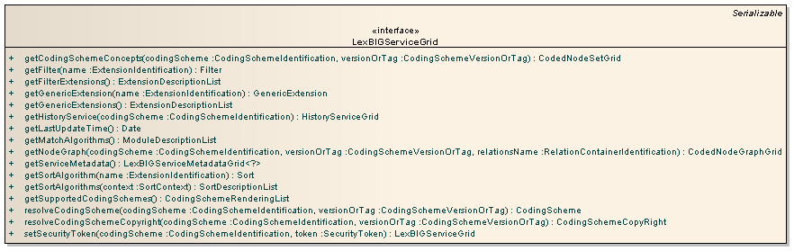

UML Diagram – Interface CodedNodeSetGrid (LE_I_02)
Link to: UML

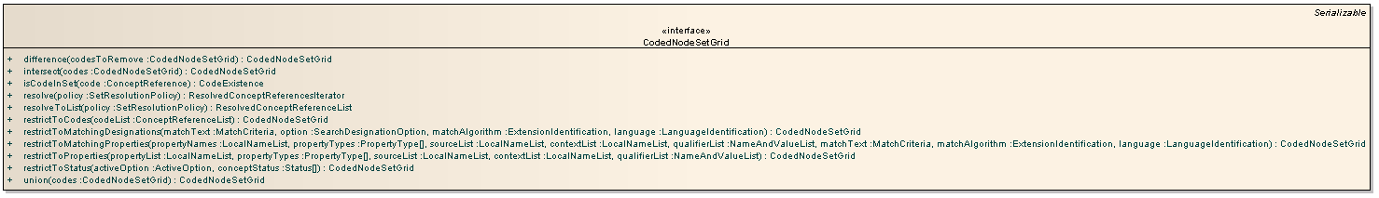

UML Diagram – Interface CodedNodeGraphGrid (LE_I_03)
Link to: UML

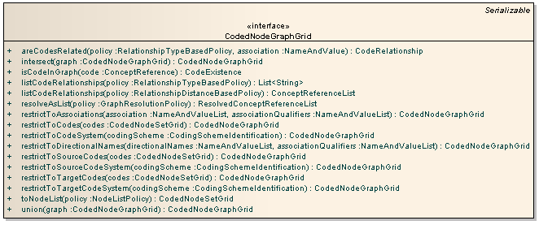

UML Diagram – Interface LexBIGServiceMetadataGrid (LE_I_05)
Link to: UML

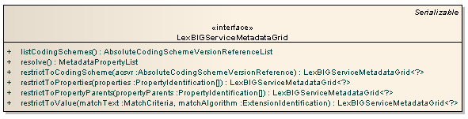

UML Diagram – Interface HistoryServiceGrid (LE_I_06)
Link to: UML

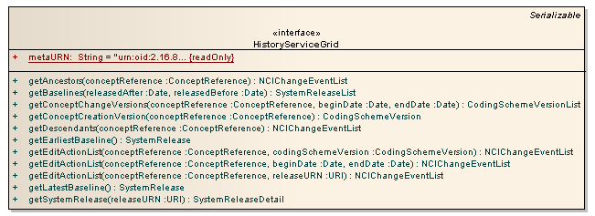

Operations Details for <Interface Name>
This section should describe in detail the operations for each of the interfaces within the service. Each operation should be listed separately and described.
NOTE: This section should be repeated for each implemented interface.

<Operation Name>
Description | An overall description on what the operation does. An activity diagram showing the details of the operation can be optionally included.
Pre-Conditions | Specify any platform specific pre-conditions for invoking this operation. (Eg. User needs to have a X.509 Grid Proxy to invoke this secured operation)
Security Controls | Describe the controls used to enforce the security requirements for this operation
Inputs | Provide the syntactic detail of the input parameters (eg. Link to XSD in GME)
Outputs | Provide the syntactic detail of the output parameters (eg. Link to XSD in GME)
Post-Conditions | Provide details about the state of the system after this operation is executed successfully. Also describe any state changes for the data types in this operation
Exception Conditions | List down all the possible exception conditions along with its error code and error message
Notes | Include additional implementation details.

Operations Details for LexBIGServiceGrid
This interface represents the core interface to a LexEVS service.
Links to: JavaDoc and UML

getCodingSchemeConcepts
Returns the set of all concepts in the specified coding scheme.
Links to: JavaDoc and Schema XSD
Behavior Description | - The starting point for Lexical based matching and queries  - Validation will ensure that:  - The Requested Coding Scheme exists in the System  - The specified version of the Coding Scheme is available  - The specified Coding Scheme is Active  - The returned CodedNodeSet is the starting point for building a lexical query.
Pre-Conditions | - The requested CodingScheme is available and Active in the System.
Inputs | - codingScheme - The local name, URI, or formal name of the requested CodingScheme  - versionOrTag - A LexGrid:CodingSchemeVersionOrTag indicating the Version or Tag of the Requested CodingScheme.  - If not provided, and there exists only one CodingScheme in the system matching the ‘codingScheme’ input, that CodingScheme will be used.  - If more than one CodingScheme in the system matches the ‘codingScheme’ input, the CodingScheme tagged as “PRODUCTION” will be used.
Outputs | - A CodedNodeSetGrid, the starting point for lexical queries.
Post-Conditions | - A CodedNodeSetGrid for the requested CodingScheme is initialized
Exception Conditions | - The requested CodingScheme is not available in the system  - The requested CodingScheme is not Active  - There are more than one CodingScheme matching the ‘codingScheme’ input, and no ‘versionOrTag’ input is provided
Note | - The resulting CodedNodeSetGrid will include codes only of ‘concept’ type. For all other types, see the operation ‘getNodeSet’

getFilter
Returns an instance of the filter extension registered with the given name
Links to: JavaDoc and Schema XSD

Behavior Description | - Returns a Filter Extension, which may be used to restrict a set of results  - Validation is carried out to ensure that:  - A Filter Extension with the given name is available and registered correctly in the system  - If all conditions are met, the Filter Extension is returned to the consumer
Pre-Conditions | - The Filter must have been properly registered as an Extension in the system
Inputs | - name – The Extension name of the requested Filter
Outputs | - Filter – an instance of the filter extension.
Post-Conditions | - The Filter Extension will be initialized and returned to the user, given the state and logic provided by the author of the Extension itself.
Exception Conditions | - The requested Filter Extension does not exist, or has not been registered properly.

getFilterExtensions
Returns a description of all registered extensions used to provide additional filtering of query results.
Links to: JavaDoc and Schema XSD

Behavior Description | - Returns a list of Filter Extension that have been registered in the system
Pre-Conditions | - Any Filter Extensions must be correctly registered as Extensions to be listed
Inputs | - none
Outputs | - An ExtensionDescriptionList, which is a list describing each Filter Extension registered within the system.
Post-Conditions | - The populated ExtensionDescriptionList will be available to the user, and each of the Extensions listed will be available to the user.
Exception Conditions | - none

getGenericExtension
Returns an instance of the application-specific extension registered with the given name.
Links to: JavaDoc and Schema XSD

Behavior Description | - Returns an application-specific Generic Extension that hasbeen registered in the system  - Validation is carried out to ensure that:  - A Generic Extension with the given name is available and registered correction in the system  - If all conditions are met, the Generic Extension is returned to the consumer
Pre-Conditions | - Any Generic Extensions must be correctly registered as Extensions to be available during the execution of this operation
Inputs | - name – the name of the requested Extension as it has be registered in the system
Outputs | - GenericExtension – an instance of the application-specific extension.
Post-Conditions | - The Generic Extension will be initialized and returned to the user, given the state and logic provided by the author of the Extension itself.
Exception Conditions | - The given ‘name’ input is:  - Not registered correction in the system  - Does not exist in the system

getGenericExtensions
Returns a description of all registered extensions used to implement application-specific behavior that is centrally accessible from a LexBIGService.
Links to: JavaDoc and Schema XSD

Behavior Description | - Returns a list of Generic Extensions that have been registered in the system  - Note: Only Generic Extensions (base class GenericExtension) will be listed here. All other classes are retrievable at the appropriate interface point (filter, sort, etc).
Pre-Conditions | - Any Generic Extensions must be correctly registered as Extensions to be listed
Inputs | - none
Outputs | - An ExtensionDescriptionList, which is a list describing each Filter Extension registered within the system.
Post-Conditions | - The populated ExtensionDescriptionList will be available to the user, and each of the Extensions listed will be available to the user.
Exception Conditions | - none

getHistoryService
Resolve a reference to the History Interface servicing the given coding scheme.
Links to: JavaDoc and Schema XSD

Behavior Description | - The entry point to the History Interface, given a requested CodingScheme  - Validation is carried out to ensure that:  - There has been History content loaded for the requested CodingScheme  - If all conditions are met, a reference to the History Interface is returned to the consumer
Pre-Conditions | - History content must have been loaded and registered in the system for the requested CodingScheme
Inputs | - codingScheme – the localName or URI of the requested CodingScheme
Outputs | - HistoryServiceGrid - a reference to the History Interface for the requested CodingScheme
Post-Conditions | - The History Interface returned to the user will be initialized for the requested CodingScheme
Exception Conditions | - If the no History exists for the requested CodingScheme

getLastUpdateTime
Return the last time that the content of this service was changed
Links to: JavaDoc and Schema XSD

Behavior Description | - Returns the time of the last content change of the system. A content change consists of any change to the vocabulary metadata or the vocabulary itself in the system.  - Note: A Tag assignment does not constitute a content change
Pre-Conditions | - History content must have been loaded and registered in the system for the requested CodingScheme
Inputs | - none
Outputs | - Date - the time of the last content change  - Note: if the system has had no registered content changes, nothing will be returned
Post-Conditions | - None
Exception Conditions | - The system has not been initialized correctly

getMatchAlgorithms
Returns the full description of all supported match algorithms.
Links to: JavaDoc and Schema XSD

Behavior Description | - A description of all Match Algorithms (if any) is returned.
Pre-Conditions | - Any Match Algorithms must be available and registered in the system to be returned
Inputs | - none
Outputs | - ModuleDescriptionList - the full description of all Match Algorithms in the system.
Post-Conditions | - none
Exception Conditions | - The system has not been initialized correctly

getNodeGraph
Returns the node graph as represented in the particular relationship set in the coding scheme
Links to: JavaDoc and Schema XSD

Behavior Description | - The starting point for relation based matching and queries  - Validation will ensure that:  - The Requested Coding Scheme exists in the System  - The specified version of the Coding Scheme is available  - The specified Coding Scheme is Active  - The returned NodeGraph is the starting point for building a relation based query.
Pre-Conditions | - The requested CodingScheme is available and Active in the System.
Inputs | - codingScheme - The local name, URI, or formal name of the requested CodingScheme  - versionOrTag - A LexGrid:CodingSchemeVersionOrTag indicating the Version or Tag of the Requested CodingScheme.  - If not provided, and there exists only one CodingScheme in the system matching the ‘codingScheme’ input, that CodingScheme will be used.  - If more than one CodingScheme in the system matches the ‘codingScheme’ input, the CodingScheme tagged as “PRODUCTION” will be used.  - relationsName - The name of the relations container to reference when generating the graph. If omitted, all native relation containers for the code system will be queried. Note: a 'native' container contains a set of associations defined by the coding scheme curators.
Outputs | - A CodedNodeGraphGrid, the starting point for relation queries.
Post-Conditions | - A CodedNodeGraphGrid for the requested CodingScheme is initialized
Exception Conditions | - The requested CodingScheme is not available in the system  - The requested CodingScheme is not Active  - There are more than one CodingScheme matching the ‘codingScheme’ input, and no ‘versionOrTag’ input is provided
Notes | - A 'native' container contains a set of associations defined by the coding scheme curators.

getServiceMetadata
Return an interface to perform system-wide query over metadata for loaded code systems and providers.
Links to: JavaDoc and Schema XSD

Behavior Description | - The entry point to the LexBIGServiceMetadata Interface
Pre-Conditions | - The LexEVS system is correctly initialized  - Any Service Metadata has be loaded and registered to the system
Inputs | - none
Outputs | - LexBIGServiceMetadataGrid - a reference to the LexBIGServiceMetadataGrid Interface
Post-Conditions | - The LexBIGServiceMetadataGrid Interface is returned to the user will be initialized for the underlying system, with all loaded and registered metadata available for queries
Exception Conditions | - Exceptions will occur if:  - The underlying system fails to initialize  - The LexBIGServiceMetadataGrid Interface fails to initialize  - There has be invalid metadata loaded to the system

getSortAlgorithm
Returns an instance of the sort extension registered with the given name
Links to: JavaDoc and Schema XSD

Behavior Description | - Returns a Sort Interface, which may be used to sort a set of results  - Validation is carried out to ensure that:  - A Sort algorithm with the given name is available and registered in the system  - If all conditions are met, the Sort Algorithm is returned to the consumer
Pre-Conditions | - Any Sort Algorithms must be available and registered in the system to be returned
Inputs | - name – the Sort Algorithm name, as it has be registered in the system
Outputs | - Sort – an instance of the sort extension.
Post-Conditions | - The fully initialized Sort Algorithm is returned to the consumer
Exception Conditions | - The input ‘name’ does not pass validation as noted above

getSortAlgorithms
Returns a description of all registered extensions used to provide additional sorting of query results in the given context.
Links to: JavaDoc and Schema XSD

Behavior Description | - Returns a list of Sort Algorithms that have been registered in the system  - Validation is carried out to ensure that:  - The context provided (if any) is a valid SortContext  - If all conditions are met, the list of descriptions of the registered Sort Algoritms is returned to the user
Pre-Conditions | - Any Sort Algorithms must be available and registered in the system to be returned
Inputs | - context – the SortContext to restrict results to. If not provided, no SortContext restriction will be considered
Outputs | - SortDescriptionList - The list of descriptions of the registered Sort Algoritms in the system
Post-Conditions | - None
Exception Conditions | - The input ‘context’ does not pass validation as noted above

getSupportedCodingSchemes
Return a list of coding schemes and versions that are supported by this service, along with their status
Links to: JavaDoc and Schema XSD

Behavior Description | - Returns a list of CodingSchemes that have been registered in the system
Pre-Conditions | - CodingSchemes available to be returned via this operation must be loaded and registered correctly in the system
Inputs | - None
Outputs | - CodingSchemeRenderingList - The list of CodingScheme descriptions and versions for every correctly loaded and registered CodingScheme in the system
Post-Conditions | - none
Exception Conditions | - The underlying system fails to initialize

resolveCodingScheme
Return detailed coding scheme information given a specific tag or version identifier.
Links to: JavaDoc and Schema XSD

Behavior Description | - Returns the LexGrid:CodingScheme given the input parameters  - Validation will ensure that:  - The Requested Coding Scheme exists in the System  - The specified version of the Coding Scheme is available  - The specified Coding Scheme is Active
Pre-Conditions | - The requested CodingScheme:  - Has been loaded and registered in the system  - Is Active
Inputs | - codingScheme - The local name, URI, or formal name of the requested CodingScheme  - versionOrTag - A LexGrid:CodingSchemeVersionOrTag indicating the Version or Tag of the Requested CodingScheme.  - If not provided, and there exists only one CodingScheme in the system matching the ‘codingScheme’ input, that CodingScheme will be used.  - If more than one CodingScheme in the system matches the ‘codingScheme’ input, the CodingScheme tagged as “PRODUCTION” will be used.
Outputs | - The LexGrid:CodingScheme give the requested inputs
Post-Conditions | - A LexGrid:CodingScheme matching the requested parameters is returned
Exception Conditions | - The underlying system fails to initialize, or the input parameters fail to validate as described above
Note | - Because of size concerns, the LexGrid:CodingScheme may or may not be fully populated, based on the underlying implementation. For example, all LexGrid:Entities may not be returned, as the size would be prohibitive for the the intent of this operation

resolveCodingSchemeCopyright
Return coding scheme copyright given a specific tag or version identifier
Links to: JavaDoc and Schema XSD

Behavior Description | - Returns the Copyright representation of the requested CodingScheme  - Validation will ensure that:  - The Requested Coding Scheme exists in the System  - The specified version of the Coding Scheme is available  - The specified Coding Scheme is Active
Pre-Conditions | - The requested CodingScheme:  - Has been loaded and registered in the system  - Is Active
Inputs | - codingScheme - The local name, URI, or formal name of the requested CodingScheme  - versionOrTag - A LexGrid:CodingSchemeVersionOrTag indicating the Version or Tag of the Requested CodingScheme.  - If not provided, and there exists only one CodingScheme in the system matching the ‘codingScheme’ input, that CodingScheme will be used.  - If more than one CodingScheme in the system matches the ‘codingScheme’ input, the CodingScheme tagged as “PRODUCTION” will be used.
Outputs | - The LexGrid:CodingSchemeCopyRight – the copyright of the coding scheme given the requested inputs
Post-Conditions | - A representation of the Copyright of the requested CodingScheme is returned and available to the user
Exception Conditions | - The underlying system fails to initialize, or the input parameters fail to validate as described above
Note | - If the implementation provides any security measures to restrict access to CodingSchemes (for example, restrict CodingScheme access based on the license of the CodingScheme), this operation should not be constrained by these security measures. The intent is to show Copyrights even for security protected CodingSchemes

setSecurityToken
Return coding scheme copyright given a specific tag or version identifier
Links to: JavaDoc and Schema XSD

Behavior Description | - Registers a security token for a coding scheme.
Pre-Conditions | - The requested CodingScheme:  - Has been loaded and registered in the system  - Is Active
Inputs | - codingScheme - The local name, URI, or formal name of the requested CodingScheme  - token - The assigned security token.
Outputs | - LexBIGServiceGrid – an instance of LexBIGServiceGrid.
Post-Conditions | - A instance of the LexBIGServiceGrid of the requested CodingScheme is returned and available to the user.
Exception Conditions | - The underlying system fails to initialize, or the input parameters fail to validate as described above
Note

Operations Details for CodedNodeGraphGrid
A virtual graph where the edges represent associations and the nodes represent coded entries. A CodedNodeGraph describes a graph that can be combined with other graphs, queried or resolved into an actual graph rendering
Links to: JavaDoc and UML

areCodesRelated
Determine whether there is an directed edge (or transitive closure of an edge) from the source code to the target code in this graph. The last parameter determines whether only direct associations are considered or whether the transitive closure of the edge is used.
Links to: JavaDoc and Schema XSD
Behavior Description | - Determine whether there is an directed edge (or transitive closure of an edge) from the source code to the target code in this graph.  - The last parameter determines whether only direct associations are considered or whether the transitive closure of the edge is used.
Pre-Conditions | - The CodedNodeGraph has been initialized for the given CodingScheme
Inputs | - policy - Policy for resolving the relationship  - association - Identifies the association to be tested. The name and value will be compared against the local name and URN of supported associations for participating coding schemes.
Outputs | - CodeRelationship
Post-Conditions | - none
Exception Conditions | - The underlying system fails to initialize, or the input parameters fail to validate as described above

intersect
Return the set of nodes and associations that are present in both graphs.
Links to: JavaDoc and Schema XSD

Behavior Description | - Adds a Intersect Restriction to the CodedNodeGraphGrid
Pre-Conditions | - Both the target CodedNodeGraphGrid and the source CodedNodeGraphGrid involved in the Intersection have been properly initialized.
Inputs | - graph  Identifies the CodedNodeGraphGrid to be intersected with.
Outputs | - A new CodedNodeGraphGrid representing the intersection result.
Post-Conditions | - The resulting CodedNodeGraphGrid is properly initialized and able to be resolved.  - Any restrictions placed on the CodedNodeGraphGrid involved in the restriction are preserved
Exception Conditions | - The underlying system fails to initialize

isCodeInGraph
Determine whether the supplied code is in the graph.
Links to: JavaDoc and Schema XSD

Behavior Description | - Returns whether or not, given the restrictions that have currently been place on the CodedNodeGraphGrid, the given node exists in the graph
Pre-Conditions | - The CodedNodeGraphGrid has been initialized, and all appropriated Restrictions have been placed on the graph prior to invoking this operation
Inputs | - code  Identifies the coding scheme and code to test.
Outputs | - CodeExistance - True if the code is present; otherwise False.
Post-Conditions | - The original CodedNodeGraphGrid is unchanged, and maybe be Restricted further, or Resolved.
Exception Conditions | - The underlying system fails to initialize

listCodeRelationships
Return a list of all of the associations in the graph that have the supplied source and target codes or, if directOnly is false, all associations whose transitive closure has the supplied associations.
Links to: JavaDoc and Schema XSD

Behavior Description | - Computes node edges, as described above.  - Note: all Restrictions placed on the graph (if any) will be respected and incorporated into node relationship calculations
Pre-Conditions | - The CodedNodeGraphGrid has been initialized, and all appropriated Restrictions have been placed on the graph prior to invoking this operation
Inputs | - policy - Policy for resolving the relationship
Outputs | - List - The list of code references for matching associations
Post-Conditions | - The original CodedNodeGraphGrid is unchanged, and maybe be Restricted further, or Resolved.
Exception Conditions | - The underlying system fails to initialize
Note | - Note that while the class of the returned value appears to imply concepts only, each contained reference inherits from the more general CodedNodeReference and is capable of representing any type of node contained by the graph.

listCodeRelationships
Return a list of all of the associations in the graph that have the supplied source and target codes based on distance between them. Distance (or the No. of edges) for a direct association between a source and target codes is 1. Values if distance should be equal or greater than 1, otherwise exception is thrown. Resulting list is not based on associations source & target have, but on distance only.
Links to: JavaDoc and Schema XSD

Behavior Description | - Computes node edges, as described above.  - Note: all Restrictions placed on the graph (if any) will be respected and incorporated into node relationship calculations
Pre-Conditions | - The CodedNodeGraphGrid has been initialized, and all appropriated Restrictions have been placed on the graph prior to invoking this operation
Inputs | - policy - Policy for resolving the relationship
Outputs | - ConceptReferenceList - The list of code references for matching associations
Post-Conditions | - The original CodedNodeGraphGrid is unchanged, and maybe be Restricted further, or Resolved.
Exception Conditions | - The underlying system fails to initialize
Note | - Note that while the class of the returned value appears to imply concepts only, each contained reference inherits from the more general CodedNodeReference and is capable of representing any type of node contained by the graph.

resolveAsList
Resolve all of the coded nodes in the list, sorting by the supplied property (if any), resolving the supplied properties, resolving coded entries to the supplied depth and resolving associations to the supplied depth.
Links to: JavaDoc and Schema XSD

Behavior Description | - Returns the underlying graph, given any placed Restrictions, as described above  - Validation will ensure that:  - The Requested CodingScheme exists in the system  - The Requested CodingScheme is not Active within the system.  - If no focus is provided, parameters ‘resolveForward’ OR ‘resolveBackward’ may be True, or neither may be True, but both may not be True  - ‘propertyNames’ are valid for the CodingScheme  - ‘sortOptions’ are registered and available as Sort Extensions
Pre-Conditions | - The CodedNodeGraphGrid has been initialized, and all appropriated Restrictions have been placed on the graph prior to invoking this operation
Inputs | - policy - Policy for resolving the relationship
Outputs | ResolvedConceptReferenceList - A list of code references, up to the maximum number specified in the policy. Note that in the event that a maximum number 'n' is specified and exactly 'n' items are returned, there is currently no flag or notification provided to indicate whether all available items were returned. Each entry will include basic information for the node along with an embedded object (e.g. concept) populated with requested properties.
Post-Conditions | - The original CodedNodeGraphGrid is unchanged, and maybe be Restricted further, or Resolved again.
Exception Conditions | - The underlying system fails to initialize
Note | - Note that while the class of the returned value appears to imply concepts only, each contained reference inherits from the more general CodedNodeReference and is capable of representing any type of node contained by the graph.

restrictToAssociations
Restrict the graph to the nodes that participate as a source or target of the named association and, if supplied, the named association qualifiers.
Links to: JavaDoc and Schema XSD

Behavior Description | - Places an association specific Restriction on the graph, as described above  - Validation will ensure that:  - The associations provided are valid associations for the CodingScheme  - The association qualifiers provided (if any) are valid association qualifiers for the CodingScheme  - Returns a new CodedNodeGraphGrid representing the filtered result.
Pre-Conditions | - The CodedNodeGraph has been initialized
Inputs | - Association  List of associations used to restrict the graph. The name and value for each item in the list will be compared against the local name and URN of supported associations for participating coding schemes.  - associationQualifiers  If supplied, restriction only applies to associations that are qualified by one or more of the supplied qualifiers. The name and value for each item in the list will be compared against the local name and URN of supported association qualifiers for participating coding schemes.
Outputs | - CodedNodeGraphGrid - representing the filtered result
Post-Conditions | - The CodedNodeGraphGrid may be Restricted further, or Resolved.
Exception Conditions | - The underlying system fails to initialize, or the input parameters fail to validate as described above

restrictToDirectionalNames
Restrict the graph to the nodes that participate as a source or target of an association whose directional name matches the one provided and, if supplied, the named association qualifiers. A directional name is considered to be either the forward or reverse label registered to an association defined by the ontology. Forward and reverse names are optionally assigned to each association. For example, an association 'lineage' may have a forward name 'ancestorOf' and reverse name 'descendantOf'
Links to: JavaDoc and Schema XSD

Behavior Description | - Places an association specific Restriction on the graph, as described above  - Validation will ensure that:  - The associations provided are valid associations for the CodingScheme  - The association qualifiers provided (if any) are valid association qualifiers for the CodingScheme  - Returns a new CodedNodeGraphGrid representing the filtered result.
Pre-Conditions | - The CodedNodeGraphGrid has been initialized
Inputs | - directionalNames  List of directionalNames used to restrict the graph. A directional name is compared against the forward and reverse names for defined associations. If a given name matches more than one forward or reverse label, all corresponding associations are included in the restriction.  - associationQualifiers  If supplied, restriction only applies to associations that are qualified by one or more of the supplied qualifiers. The name and value for each item in the list will be compared against the id and URN of supported association qualifiers for participating coding schemes.
Outputs | - CodedNodeGraphGrid representing the filtered result
Post-Conditions | - The CodedNodeGraphGrid may be Restricted further, or Resolved.
Exception Conditions | - The underlying system fails to initialize, or the input parameters fail to validate as described above

restrictToCodes
Return a graph that contains only the codes that are present in the supplied list, and all edges that still have a source and target code remaining.
Links to: JavaDoc and Schema XSD

Behavior Description | - Places an association specific Restriction on the graph, as described above  - Returns a new CodedNodeGraphGrid representing the filtered result.
Pre-Conditions | - The CodedNodeGraph has been initialized
Inputs | - codes  Codes to filter on.
Outputs | - CodedNodeGraphGrid representing the filtered result
Post-Conditions | - The CodedNodeGraphGrid may be Restricted further, or Resolved.
Exception Conditions | - The underlying system fails to initialize, or the input parameters fail to validate as described above

restrictToCodeSystem
Restrict the graph to codes (source and target) that originate from the supplied code system. Note: edges defined by other code systems will still be resolved if associated with both source and target nodes for the restricted code system.
Links to: JavaDoc and Schema XSD

Behavior Description | - Places an association specific Restriction on the graph, as described above  - Returns a new CodedNodeGraphGrid representing the filtered result.
Pre-Conditions | - The CodedNodeGraphGrid has been initialized
Inputs | - codingScheme  The local name or URN of the coding scheme to filter on.
Outputs | - CodedNodeGraphGrid representing the filtered result
Post-Conditions | - The CodedNodeGraphGrid may be Restricted further, or Resolved.
Exception Conditions | - The underlying system fails to initialize

restrictToSourceCodes
Restrict the graph to associations that have one of the codes in the supplied list as source codes.
Links to: JavaDoc and Schema XSD

Behavior Description | - Places an association specific Restriction on the graph, as described above  - Returns a new CodedNodeGraphGrid representing the filtered result.
Pre-Conditions | - The CodedNodeGraph has been initialized
Inputs | - codes  Codes to filter on.
Outputs | - CodedNodeGraphGrid representing the filtered result
Post-Conditions | - The CodedNodeGraphGrid may be Restricted further, or Resolved.
Exception Conditions | - The underlying system fails to initialize

restrictToSourceCodeSystem
Restrict the graph to edges that have codes from the specified code system as a source.
Links to: JavaDoc and Schema XSD

Behavior Description | - Places an association specific Restriction on the graph, as described above  - Returns a new CodedNodeGraphGrid representing the filtered result.
Pre-Conditions | - The CodedNodeGraph has been initialized
Inputs | - codingScheme  The local name or URN of the coding scheme to filter on.
Outputs | - CodedNodeGraphGrid representing the filtered result
Post-Conditions | - The CodedNodeGraphGrid may be Restricted further, or Resolved.
Exception Conditions | - The underlying system fails to initialize

restrictToTargetCodes
Restrict the graph to associations that have one of the codes in the supplied list as target codes.
Links to: JavaDoc and Schema XSD

Behavior Description | - Places an association specific Restriction on the graph, as described above  - Returns a new CodedNodeGraphGrid representing the filtered result.
Pre-Conditions | - The CodedNodeGraph has been initialized
Inputs | - codes  Codes to filter on.
Outputs | - CodedNodeGraphGrid representing the filtered result
Post-Conditions | - The CodedNodeGraphGrid may be Restricted further, or Resolved.
Exception Conditions | - The underlying system fails to initialize

restrictToTargetCodeSystem
Restrict the graph to edges that have codes from the specified code system as a target.
Links to: JavaDoc and Schema XSD

Behavior Description | - Places an association specific Restriction on the graph, as described above  - Returns a new CodedNodeGraphGrid representing the filtered result.
Pre-Conditions | - The CodedNodeGraphGrid has been initialized
Inputs | - codingScheme  The local name or URN of the coding scheme to filter on.
Outputs | - CodedNodeGraphGrid representing the filtered result
Post-Conditions | - The CodedNodeGraphGrid may be Restricted further, or Resolved.
Exception Conditions | - The underlying system fails to initialize

toNodeList
Transform the graph into a simple of list of code references, removing all association information.
Links to: JavaDoc and Schema XSD

Behavior Description | - Returns the underlying graph as a list of nodes, given any placed Restrictions.  - Validation will ensure that:  - The Requested CodingScheme exists in the system  - The Requested CodingScheme is not Active within the system.  - If no focus is provided, parameters ‘resolveForward’ OR ‘resolveBackward’ may be True, or neither may be True, but both may not be True
Pre-Conditions | - The CodedNodeGraphGrid has been initialized, and all appropriated Restrictions have been placed on the graph prior to invoking this operation
Inputs | - policy - Policy for resolving the relationship
Outputs | CodedNodeSetGrid - A set with matching items, up to the maximum number specified in the policy. Note that in the event that a maximum number 'n' is specified and exactly 'n' items are returned, there is currently no flag or notification provided to indicate whether all available items were returned.
Post-Conditions | - The original CodedNodeGraphGrid is unchanged, and maybe be Restricted further, or Resolved again.
Exception Conditions | - The underlying system fails to initialize, or the input parameters fail to validate as described above

union
Return the union of the two graphs. Union, in this context, means that the resulting graph contains the unique set of coded entries (String independent) that are present in one or both of the graphs, and the unique combination of edges (associations) present in one or both of the graphs.
Links to: JavaDoc and Schema XSD

Behavior Description | - Adds a Union Restriction to the CodedNodeGraphGrid
Pre-Conditions | - Both the target CodedNodeGraphGrid and the source CodedNodeGraphGrid involved in the Union have been properly initialized.
Inputs | - graph  Identifies the CodedNodeGraphGrid to be unioned.
Outputs | - CodedNodeGraphGrid representing the merged result.
Post-Conditions | - The resulting CodedNodeGraphGrid is properly initialized and able to be resolved.  - Any restrictions placed on the CodedNodeGraphGrid involved in the restriction are preserved
Exception Conditions | - The underlying system fails to initialize

Operations Details for CodedNodeSetGrid
A coded node set represents a flat list of coded entries.
Links to: JavaDoc and UML

difference
Return a coded node set that represents the set of concepts in this coded node set that are not included by the given set of codes.
Links to: JavaDoc and Schema XSD

Behavior Description | - Returns the difference of two CodedNodeSetGrid, given the input criteria
Pre-Conditions | - Both CodedNodeSetGrid participating in the difference operation have been initialized for the given CodingScheme
Inputs | - codesToRemove –  List of codes to remove from the surrounding set.
Outputs | - CodedNodeSetGrid representing the difference.
Post-Conditions | - The resulting CodedNodeSetGrid is properly initialized and able to be resolved.  - Any restrictions placed on the CodedNodeSetGrid involved in the restriction are preserved
Exception Conditions | - The underlying system fails to initialize, or the input parameters fail to validate as described above

intersect
Return a coded node set that represents the set of concepts that this node set and the provided node set have in common.
Links to: JavaDoc and Schema XSD

Behavior Description | - Returns the intersection of two CodedNodeSetGrid, given the input criteria
Pre-Conditions | - Both CodedNodeSetGrid participating in the intersection operation have been initialized for the given CodingScheme
Inputs | - codes –  Set of codes to intersect
Outputs | - CodedNodeSetGrid representing the intersection result
Post-Conditions | - The resulting CodedNodeSetGrid is properly initialized and able to be resolved.  - Any restrictions placed on the CodedNodeSetGrid involved in the restriction are preserved
Exception Conditions | - The underlying system fails to initialize, or the input parameters fail to validate as described above

isCodeInSet
Return true if the supplied concept reference is contained within the represented list.
Links to: JavaDoc and Schema XSD

Behavior Description | - Returns whether or not, given the restrictions that have currently been place on the CodedNodeSetGrid, the given node exists in the graph
Pre-Conditions | - The CodedNodeSetGrid has been initialized, and all appropriated Restrictions have been placed on the set prior to invoking this operation
Inputs | - Code  Coding scheme and concept code to test
Outputs | - CodeExsitance - True if the code is present; otherwise False.
Post-Conditions | - The original CodedNodeSetGrid is unchanged, and maybe be Restricted further, or Resolved.
Exception Conditions | - The underlying system fails to initialize

resolve
Resolve an iterator over concepts matching the given criteria.
Links to: JavaDoc and Schema XSD

Behavior Description | - Returns the underlying node set, given any placed Restrictions, as described above  - Validation will ensure that:  - The Requested CodingScheme exists in the system  - The Requested CodingScheme is not Active within the system.  - ‘sortOptions’ are valid and registered in the system  - ‘propertyNames’ are valid for the CodingScheme
Pre-Conditions | - The CodedNodeSetGrid has been initialized, and all appropriated Restrictions have been placed on the set prior to invoking this operation
Inputs | - policy - Policy for resolving the CodedNodeSet
Outputs | - ResolvedConceptReferencesIterator - An iterator over matching entries. Each entry will include basic information for the node along with an embedded object (e.g. concept) populated with requested properties.
Post-Conditions | - The original CodedNodeSetGrid is unchanged, and may be be Restricted further, or Resolved again.
Exception Conditions | - The underlying system fails to initialize, or the input parameters fail to validate as described above
Note | - Note that while the class of the returned value appears to imply concepts only, each contained reference inherits from the more general CodedNodeReference and is capable of representing any type of node contained by the set.

resolveToList
Resolve the set to a list of concepts sorted by the supplied parameters, resolving all of the properties named in the list.
Links to: JavaDoc and Schema XSD

Behavior Description | - Returns the underlying node set, given any placed Restrictions, as described above  - Validation will ensure that:  - The Requested CodingScheme exists in the system  - The Requested CodingScheme is not Active within the system.  - ‘sortOptions’ are valid and registered in the system  - ‘propertyNames’ are valid for the CodingScheme
Pre-Conditions | - The CodedNodeSetGrid has been initialized, and all appropriated Restrictions have been placed on the set prior to invoking this operation
Inputs | - policy - Policy for resolving the relationship
Outputs | - ResolvedConceptReferenceList - A list of node references, up to the maximum number specified. Note that in the event that a maximum number 'n' is specified and exactly 'n' items are resolved, there is currently no flag or notification provided to indicate the requested list is fully resolved.
Post-Conditions | - The original CodedNodeSetGrid is unchanged, and may be be Restricted further, or Resolved again.
Exception Conditions | - The underlying system fails to initialize, or the input parameters fail to validate as described above
Note | - Note that while the class of the returned value appears to imply concepts only, each contained reference inherits from the more general CodedNodeReference and is capable of representing any type of node contained by the set.

restrictToCodes
Restrict the set to the list of codes in the supplied reference list.
Links to: JavaDoc and Schema XSD

Behavior Description | - Places an association specific Restriction on the node set.  - Returns a new CodedNodeSetGrid representing the filtered result.
Pre-Conditions | - The CodedNodeSetGrid has been initialized
Inputs | - codeList  The list of codes to filter on.
Outputs | - CodedNodeSetGrid representing the filtered result
Post-Conditions | - The CodedNodeSetGrid may be Restricted further, or Resolved.
Exception Conditions | - The underlying system fails to initialize, or the input parameters fail to validate as described above

restrictToMatchingDesignations
Restrict the list to the set of concepts that have designations that match the supplied string, using the supplied matching algorithm and language.
Links to: JavaDoc and Schema XSD

Behavior Description | - Places an association specific Restriction on the node set, as described above  - Returns a new CodedNodeSetGrid representing the filtered result.  - Validation will ensure that:  - ‘matchAlgorithm’ is valid and registered in the system
Pre-Conditions | - The CodedNodeSetGrid has been initialized
Inputs | - matchText –  Filter String - syntax is determined by the match algorithm  - option –  Indicates the designations to search (one of the enumerated type SearchDesignationOption).  - matchAlgorithm –  Local name of the match algorithm - possible algorithms are returned in LexBigService.getMatchAlgorithms().  - language –  Language of search string. If missing, use the default language specified in the context.
Outputs | - CodedNodeSetGrid representing the filtered result
Post-Conditions | - The CodedNodeSetGrid may be Restricted further, or Resolved.
Exception Conditions | - The underlying system fails to initialize, or the input parameters fail to validate as described above

restrictToMatchingProperties
Remove all elements from the set that do not have one or more properties that match the given criteria. Note that while property name and type are often synchronized, the API allows for them to be differentiated. For concepts, there are 5 major types of properties that can be assigned ('Comments', 'Definitions', 'Instructions', 'Presentations', and 'Generic' properties which can represent vocabulary-specific name/value pairings). Often the name assigned to a property will match the property type (e.g. a Presentation named 'textualPresentation' or a Definition named 'definition'). However, names are not fixed (e.g. a Presentation property may be named 'text' or 'textualPresentation'). This method allows for query based on property name, type, or both. However, at least one name or type must be specified.
Links to: JavaDoc and Schema XSD

Behavior Description | - Places an association specific Restriction on the node set, as described above  - Returns a new CodedNodeSetGrid representing the filtered result.  - Validation will ensure that:  - ‘propertyNames’ are valid and registered in the system  - ‘matchAlgorithm’ is valid and registered in the system
Pre-Conditions | - The CodedNodeSetGrid has been initialized
Inputs | - propertyNames –  Indicates the local names of properties to match. To be recognized, each provided name must be defined in the coding scheme metadata as part of the registered supported properties. If empty or null, all names are evaluated for the specified property types.  Note that the meta-property 'conceptCode' can be specified in addition to specific named properties defined by the code system.  If 'conceptCode' is specified, the matchAlgorithms 'exactMatch', 'contains' and 'luceneQuery' and 'RegExp' are allowed. Any other request results in 'luceneQuery' being used.  - propertyTypes –  Indicates whether to match specific property categories, regardless of the assigned name. Any of the enumerated PropertyType values can be specified. If empty or null, properties of all types are evaluated.  - sourceList –  Local names of sources to match; each must be defined in the supported sources for the coding scheme. Returned values must match at least one of the specified values. A null or empty value indicates to match against all available sources.  - contextList –  Local names of usage contexts to match; each must be defined in the supported contexts for the coding scheme. Returned values must match at least one of the specified values. A null or empty value indicates to match against all available contexts.  - qualifierList –  Name/value pairings of property qualifiers to match. Each name must be defined in the supported property qualifiers for the coding scheme. Returned values must match at least one of the name/value combinations. A null or empty value indicates to match against all property qualifiers.  - matchText –  Property text to match - syntax is determined by the algorithm.  - matchAlgorithm –  Local name of the match algorithm - possible algorithms are returned in LexBigService.getMatchAlgorithms().  - language –  Language of search string. If missing, use the default language specified in the context.
Outputs | - CodedNodeSetGrid representing the filtered result
Post-Conditions | - The CodedNodeSetGrid may be Restricted further, or Resolved.
Exception Conditions | - The underlying system fails to initialize, or the input parameters fail to validate as described above

restrictToProperties
Remove all elements from the set that don't have one or more properties that match the given criteria. Note that while property name and type are often synchronized, the API allows for them to be differentiated. For concepts, there are 5 major types of properties that can be assigned ('Comments', 'Definitions', 'Instructions', 'Presentations', and 'Generic' properties which can represent vocabulary-specific name/value pairings). Often the name assigned to a property will match the property type (e.g. a Presentation named 'textualPresentation' or a Definition named 'definition'). However, names are not fixed (e.g. a Presentation property may be named 'text' or 'textualPresentation'). This method allows for query based on property name, type, or both. However, at least one name or type must be specified.
Links to: JavaDoc and Schema XSD

Behavior Description | - Places an association specific Restriction on the node set.  - Returns a new CodedNodeSetGrid representing the filtered result.  - Validation will ensure that:  - ‘propertyNames’ are valid and registered in the system
Pre-Conditions | - The CodedNodeSet has been initialized
Inputs | - propertyList –  Local names of properties to use in restriction; each must be defined in the supported properties for the coding scheme.  - propertyTypes –  Indicates whether to match specific property categories, regardless of the assigned name. Any of the enumerated PropertyType values can be specified. If empty or null, properties of all types are evaluated.  - sourceList –  Local names of sources to match; each must be defined in the supported sources for the coding scheme. Returned values must match at least one of the specified values. A null or empty value indicates to match against all available sources.  - contextList –  Local names of usage contexts to match; each must be defined in the supported contexts for the coding scheme. Returned values must match at least one of the specified values. A null or empty value indicates to match against all available contexts.  - qualifierList –  Name/value pairings of property qualifiers to match. Each name must be defined in the supported property qualifiers for the coding scheme. Returned values must match at least one of the name/value combinations. A null or empty value indicates to match against all property qualifiers.
Outputs | - CodedNodeSetGrid representing the filtered result
Post-Conditions | - The CodedNodeSetGrid may be Restricted further, or Resolved.
Exception Conditions | - The underlying system fails to initialize, or the input parameters fail to validate as described above

restrictToStatus
Restrict the set to concepts matching the given status criteria.
Links to: JavaDoc and Schema XSD

Behavior Description | - Places an association specific Restriction on the node set, as described above  - Returns a new CodedNodeSetGrid representing the filtered result.
Pre-Conditions | - The CodedNodeSetGrid has been initialized
Inputs | - activeOption –  Indicates whether to include active codes, inactive codes, or both in the resolved result set (one of the enumerated type ActiveOption). This is matched against the 'isActive' field for CodedEntry instances in the code system.  - status –  Indicates zero or more status values to match. Provided values are compared using an exact match algorithm against the 'status' field for matching entities. If null or empty, the restriction is evaluated based only on the specified activeOption.
Outputs | - CodedNodeSetGrid representing the filtered result
Post-Conditions | - The CodedNodeSetGrid may be Restricted further, or Resolved.
Exception Conditions | - The underlying system fails to initialize, or the input parameters fail to validate as described above

union
Return the set union of all of the codes in the containing or the referenced set
Links to: JavaDoc and Schema XSD

Behavior Description | - Adds a Union Restriction to the CodedNodeSetGrid
Pre-Conditions | - Both the target CodedNodeSetGrid and the source CodedNodeSetGrid involved in the Union have been properly initialized.
Inputs | - codes  Codes to add to the union
Outputs | - CodedNodeSetGrid representing the merged result.
Post-Conditions | - The resulting CodedNodeSetGrid is properly initialized and able to be resolved.  - Any restrictions placed on the CodedNodeSetGrid involved in the restriction are preserved
Exception Conditions | - The underlying system fails to initialize

Operations Details for LexBIGServiceMetadataGrid
Interface to perform system-wide query over metadata for loaded code systems and providers.
Links to: JavaDoc and UML

listCodingSchemes
List the coding schemes that are represented in the metadata index.
Links to: JavaDoc and Schema XSD

Behavior Description | - Query the available service metadata, as described above
Pre-Conditions | - The LexBIGServiceMetadataGrid service has been initialized correctly
Inputs | - none
Outputs | - A LexBIG:AbsoluteCodingSchemeVersionReferenceList indicating the loaded service metadata
Post-Conditions | - none
Exception Conditions | - The LexBIGServiceMetadataGrid service, or underlying LexEVS service fail to initialize

restrictToCodingScheme
Restrict the search to a particular coding scheme.
Links to: JavaDoc and Schema XSD

Behavior Description | - Add a Restriction to the available service metadata, as described above
Pre-Conditions | - The LexBIGServiceMetadataGrid service has been initialized correctly
Inputs | - acsvr –  The coding scheme to restrict the search to. You may provide the URN, the version, or both.
Outputs | - A new LexBIGServiceMetadataGrid representing the restricted result.
Post-Conditions | - The LexBIGServiceMetadataGrid may be Restricted further, or Resolved
Exception Conditions | - The LexBIGServiceMetadataGrid service, or underlying LexEVS service fail to initialize

restrictToProperties
Restrict the search to a particular property. Currently, this can be any element or attribute name from the OBO metadata schema
Links to: JavaDoc and Schema XSD

Behavior Description | - Add a Restriction to the available service metadata, as described above
Pre-Conditions | - The LexBIGServiceMetadataGrid service has been initialized correctly
Inputs | - properties –  The set of properties to restrict the search to. If you provide multiple properties, it is treated as an OR search.
Outputs | - A new LexBIGServiceMetadataGrid representing the restricted result.
Post-Conditions | - The LexBIGServiceMetadataGrid may be Restricted further, or Resolved
Exception Conditions | - The LexBIGServiceMetadataGrid service, or underlying LexEVS service fail to initialize

restrictToPropertyParents
Restrict the search by the parents of the metadata elements. The OBO MetaData format is hierarchial - if you wish to restrict your search to properties that are under another property, provide the required property containers here.
Links to: JavaDoc and Schema XSD

Behavior Description | - Add a Restriction to the available service metadata, as described above
Pre-Conditions | - The LexBIGServiceMetadataGrid service has been initialized correctly
Inputs | - propertyParents –  The containers to require as parents. For example, to restrict the search to "contacts" that are under "about" that is under "authority" - provide "authority" and "about". The order of the parents does not matter. Multiple parents are treated as an AND - so the result is required to be under each of the parents going up the parent tree.
Outputs | - A new LexBIGServiceMetadataGrid representing the restricted result.
Post-Conditions | - The LexBIGServiceMetadataGrid may be Restricted further, or Resolved
Exception Conditions | - The LexBIGServiceMetadataGrid service, or underlying LexEVS service fail to initialize

restrictToValue
Restrict the result to the metadata elements that match the supplied string, using the supplied matching algorithm
Links to: JavaDoc and Schema XSD

Behavior Description | - Add a Restriction to the available service metadata.  - Validation will ensure that:  - ‘matchAlgorithm’ is valid and registered in the system
Pre-Conditions | - The LexBIGServiceMetadataGrid service has been initialized correctly
Inputs | - matchText –  The match text. Format is determined by the match algorithm.  - matchAlgorithm –  Local name of the match algorithm - possible algorithms are returned in LexBigService.getMatchAlgorithms().
Outputs | - A new LexBIGServiceMetadataGrid representing the restricted result.
Post-Conditions | - The LexBIGServiceMetadataGrid may be Restricted further, or Resolved
Exception Conditions | - The LexBIGServiceMetadataGrid service, or underlying LexEVS service fail to initialize, or the input parameters fail to validate as described above

resolve
Apply all of the restrictions, and return the result
Links to: JavaDoc and Schema XSD

Behavior Description | - Returns the underlying MetadataPropertyList, given any placed Restrictions, as described above
Pre-Conditions | - The LexBIGServiceMetadataGrid service has been initialized correctly
Inputs | - none
Outputs | - The resulting MetadataPropertyList
Post-Conditions | - The LexBIGServiceMetadata may be Restricted further, or Resolved again
Exception Conditions | - The LexBIGServiceMetadata service, or underlying LexEVS service fail to initialize

Operations Details for HistoryServiceGrid
The history service returns information about the change history of a coding scheme.
Links to: JavaDoc and UML

getAncestors

Return a list of baselines supported by this service that were released on or after the first supplied date and were released on or before the second date. Returned baselines are arranged in sequential order, from earliest to latest.
Links to: JavaDoc and Schema XSD

Behavior Description | - Query the available History service, as described above
Pre-Conditions | - The History service has been initialized correctly
Inputs | - conceptReference–  The reference from which to begin the query.
Outputs | - A LexBIG:NCIChangeEventList containing the ancestors of the given ‘conceptReference’ parameter
Post-Conditions | - The HistoryService service state is maintained and may be queried again
Exception Conditions | - The History service, or underlying LexEVS service fail to initialize

getBaselines
Return a list of baselines supported by this service that were released on or after the first supplied date and were released on or before the second date. Returned baselines are arranged in sequential order, from earliest to latest.
Links to: JavaDoc and Schema XSD

Behavior Description | - Query the available History service, as described above
Pre-Conditions | - The History service has been initialized correctly
Inputs | - releasedAfter  If present, only return baselines released on or after the supplied date.  - releasedBefore  If present, only return baselines that were released before the specified date
Outputs | - A LexBIG:SystemReleaseList containing the baselines of the given parameters
Post-Conditions | - The HistoryService service state is maintained and may be queried again
Exception Conditions | - The History service, or underlying LexEVS service fail to initialize

getConceptChangeVersions

Return a list of all of the coding scheme versions in which the supplied concept changed between the two supplied times (inclusive).
Links to: JavaDoc and Schema XSD

Behavior Description | - Query the available History service, as described above
Pre-Conditions | - The History service has been initialized correctly
Inputs | - conceptReference  The concept to pull the versions out of  - beginDate  Begin date (inclusive) to check for version changes. If omitted, go to earliest recorded date  - endDate  Last date to check for changes in (inclusive). If omitted include all dates past and including beginDate
Outputs | - A CodingSchemeVersionList
Post-Conditions | - The HistoryService service state is maintained and may be queried again
Exception Conditions | - The History service, or underlying LexEVS service fail to initialize

getConceptCreationVersion
Return the coding scheme version in which the supplied concept was created.
Links to: JavaDoc and Schema XSD

Behavior Description | - Query the available History service, as described above
Pre-Conditions | - The History service has been initialized correctly
Inputs | - conceptReference  The concept to pull the creation version of
Outputs | - A CodingSchemeVersion
Post-Conditions | - The HistoryService service state is maintained and may be queried again
Exception Conditions | - The History service, or underlying LexEVS service fail to initialize

getDescendants
Return the list of change events identifying the immediate descendants of the given concept reference.
Links to: JavaDoc and Schema XSD

Behavior Description | - Query the available History service, as described above
Pre-Conditions | - The History service has been initialized correctly
Inputs | - conceptReference  The concept focus of the query
Outputs | - A NCIChangeEventList containing the immediate descendants of the ‘conceptReference’ parameter
Post-Conditions | - The HistoryService service state is maintained and may be queried again
Exception Conditions | - The History service, or underlying LexEVS service fail to initialize

getEarliestBaseline
Return the earliest baseline version in the list.
Links to: JavaDoc and Schema XSD

Behavior Description | - Query the available History service, as described above
Pre-Conditions | - The History service has been initialized correctly
Inputs | - none
Outputs | - A SystemRelease containing earliest baselines of the History service
Post-Conditions | - The HistoryService service state is maintained and may be queried again
Exception Conditions | - The History service, or underlying LexEVS service fail to initialize

getEditActionList
Return the list of available NCI-defined change events for the given concept and coding scheme version.
Links to: JavaDoc and Schema XSD

Behavior Description | - Query the available History service, as described above
Pre-Conditions | - The History service has been initialized correctly
Inputs | - conceptReference  Optional concept to get the action list for. If omitted, all events for the given change set (represented by a coding scheme version) are returned.  - codingSchemeVersion  Version to get the action list for
Outputs | - A NCIChangeEventList containing the change events as described above.
Post-Conditions | - The HistoryService service state is maintained and may be queried again
Exception Conditions | - The History service, or underlying LexEVS service fail to initialize

getEditActionList
Return the list of available NCI-defined change events for the given concept and date range.
Links to: JavaDoc and Schema XSD

Behavior Description | - Query the available History service, as described above
Pre-Conditions | - The History service has been initialized correctly
Inputs | - conceptReference  Optional concept to get the action list for. If omitted, all events for the given date range are returned.  - beginDate  Begin date (inclusive) to check for version changes. If omitted, go to earliest recorded date.  - endDate  Last date to check for changes in (inclusive). If omitted include all dates past and including beginDate.
Outputs | - A NCIChangeEventList containing the change events as described above.
Post-Conditions | - The HistoryService service state is maintained and may be queried again
Exception Conditions | - The History service, or underlying LexEVS service fail to initialize

getEditActionList
Return the list of NCI-defined change events for the given concept and release; empty if not applicable.
Links to: JavaDoc and Schema XSD

Behavior Description | - Query the available History service, as described above
Pre-Conditions | - The History service has been initialized correctly
Inputs | - conceptReference  Optional concept to get the action list for. If omitted the actions for all registered concepts for the specified system release are returned.  - releaseURN  URN of the system release to retrieve the action list for.
Outputs | - A NCIChangeEventList containing the change events as described above.
Post-Conditions | - The HistoryService service state is maintained and may be queried again
Exception Conditions | - The History service, or underlying LexEVS service fail to initialize

getLatestBaseline
Get the latest baseline in the list.
Links to: JavaDoc and Schema XSD

Behavior Description | - Query the available History service, as described above
Pre-Conditions | - The History service has been initialized correctly
Inputs | - none
Outputs | - A SystemRelease containing latest baselines of the History service
Post-Conditions | - The HistoryService service state is maintained and may be queried again
Exception Conditions | - The History service, or underlying LexEVS service fail to initialize

getSystemRelease
Return detailed information about the particular system release.
Links to: JavaDoc and Schema XSD

Behavior Description | - Query the available History service, as described above
Pre-Conditions | - The History service has been initialized correctly
Inputs | - releaseURN  The URN of the system release to retrieve.
Outputs | - A SystemReleaseDetail of the Release URN specified by the ‘releaseURN’ parambet
Post-Conditions | - The HistoryService service state is maintained and may be queried again
Exception Conditions | - The History service, or underlying LexEVS service fail to initialize

Message Information Model
This section describes the information model of the messages sent to the service. This should match the semantic profile detailed above. It should include a UML model showing the object model for the service. It should also include a detailed description of the model elements in a tabular format. This section should also include artifacts such as an xml schema as required for the technology binding.

Information Model
A UML diagram showing the service object model.

Information Model Description
This section should include a detailed description of the service object model. This object model is the external facing object model which the clients of the service will use to interact with the service. This can include a tabular description of objects and attributes of the service model. Any artifacts that implementers of this service need to adhere such as an xml schema or java interfaces should be referred to here.
NOTE: the following table should be repeated for each entity which acts as an input or output parameter within the Information Model. Note: Exceptions should be defined separately in the Error Handling section below
Object Name |  | AdverseEvent
Description of the Object |  | Represents the Adverse Event occurring within the system
Link to the Object Specification |  | Provide link to the XSD or the Java Interface Specifications
Attribute Name | Type | Description
Id | String / Number / II etc. | Stores the Id of the Adverse Event
… |  | …

Service Interactions
This section describes the actors involved with the service and the dynamic behavior of the service. It should include details of service behavior in all significant service interactions.
An interaction diagram illustrating the interaction should also be included in this section.

Actors
A description of the actors involved in service interactions.

Name | Type | Description
LexEVS 6.0 | System | System interacts with the service to query content in LexEVS.
Subject Registry Service |  | Uses the Subject Registry Service to retrieve additional subject information
… |  | …

Interaction Details
Provide the interaction details between this service and other actors. Describe the technology used for this interaction. Also provide the exact version of the service to be used and the data specifications to adhere to for a particular interaction. The number of consumers of the service can always increase in the future. However provide a notional interaction with a consumer below to describe the specification of the
*Producers provided the data which this service needs.
*Consumers consume the data provided by this service.
Actor Name | Producer / Consumer | Data | Link | Description
LexEVS 6.0 Analytical Grid Services | Producer | Ontology Information. | Provide link to the XSD or Java Specification defining the data element exchanged | LE 6.0 AG Service relies on Subject Registry Service to retrieve additional subject information
Scheduled Calendar Service v1.0 | Consumer | AE Information | Provide link to the XSD or Java Specification defining the data element exchanged | AE Service supplies AE information to the Treatment Plan service
… |  |  |  | …

Implementation Considerations
The following sections can optionally be used to specify any implementation specific details for this service.

Security
Provide technical specification on security requirements to access this service. This includes authentication, authorization, encryption, and other LOA requirements.
Access Control
Does the Service require Access Control mechanism to be in place to restrict access to only authenticated users or systems? | No
If Yes then provide the following in detail:
N/A
Application (Service) Security [Access Policy]
Does the Service incorporate any security controls (Authorization) to ensure that access to information is granted to only the authorized users / systems? | Yes
If Yes then provide the following in detail:
Certain vocabulary content accessible through the LexEVS Grid Service may require extra authorization to access. Each client is required to supply its own access credentials via Security Tokens. These Security Tokens are implemented by a SecurityToken object:
Name: SecurityToken
Namespace: gme://caCORE.caCORE/3.2/gov.nih.nci.evs.security
Package: gov.nih.nci.evs.security
Each call to “setSecurityToken” sets up a secured connection to Distributed LexEVS with the access privileges included in the SecurityToken parameter. The LexEVSGridServiceReference that is returned to the client contains a unique key identifier to the secure connection that has been created on the server. All subsequent calls the client makes through this LexEVSGridServiceReference will be made securely. If additional SecurityTokens are passed in through the “setSecurityToken” Grid Service, the additional security will be added and maintained.

The “setSecurityToken” Grid Service is a stateful service. This means that after the client sets a SecurityToken, any subsequent call will be applied to that SecurityToken.

Secure connections are not maintained on the server indefinitely, but are based on load conditions. The server will allow 30 unique secure connections to be set up for clients without any time limitations. As additional requests for secure connections are received by the server, connections will be released by the server on an ‘oldest first’ basis. No connection, however, may be released prior to 5 minutes after its creation.

If no SecurityTokens are passed in by the client, a non-secure Distributed LexEVS connection will be used. The server maintains one (and only one) un-secured Distributed LexEVS connection that is shared by any client not requesting security.

NOTE: All non-secured information accessed by the LexEVS Grid Service is publicly available from NCICB and users are expected to follow the licensing requirements currently in place for accessing and using NCI EVS information.
Cryptography
Does the Service require encryption of data transmitted to and from it? | No
If Yes then provide the following in detail:
N/A
Information Security and Risk Management
Is the information served by the service confidential or privileged? And if yes, is it at risk from any external threats or vulnerabilities? | No
If Yes then provide the following in detail:
N/A
Legal, Regulations, Compliance and Investigations
Does the information served by the service fall under any legal / regulatory compliance either at federal, state, local or institutional level ? | Yes
If Yes then provide the following in detail:
Users are expected to follow the licensing requirements currently in place for accessing and using NCI EVS information.
Telecommunications and Network Security
Does the service need any network or transport level security such as SSL, Firewall protection etc. | Yes
If Yes then provide the following in detail:
Firewall configurations required to provide access to the LexEVS 6.0 Analytical Grid Services.

Auditing
No auditing requirements exist for LexEVS 6.0 Analytical Grid Services.
Operation Name | Auditing Details
N/A

Entity Name | Auditing Details
N/A

Privacy
No privacy requirements exist for LexEVS 6.0 Analytical Grid Services.
Data Element | Privacy Regulation | Security Control in Place | Access Requirement
N/A

Error Handling
Provide technical specification on how the errors will be raised by the service and what information will be provided. Provide a technical model of the error conditions and its specific meaning.
In this section, provide the technical specification on how the errors will be raised by the service and what information will be provided. Provide a technical model of the error conditions and its specific meaning.
NOTE: This section should only list the errors which are to be returned to the clients. The service should provide an encapsulation boundary to all the internal errors and return only the errors which are of use to the client application.

Overview
Provide overview of the error handling and reporting mechanism for the specific implementation. Depending upon the technology used to implement the service specification, describe in detail the appropriate error reporting mechanism. E.g. In case of web services it would be web service faults or in case of EJB interface they will be Java Exceptions.

Error Object Details
Provide technology specific details about eacht attribute and its data type contained within the error object, which can be used to describe the error condition that occurred. It is recommended that each error object contain a unique code which can be used to identify the error condition programmatically. It should also be supported by a human readable message which can be used for display purposes. Also an attribute describing the criticality of the error can be present as well. Also an attribute describing the criticality of the error (FATAL, MAJOR, MINOR, etc.) can be present as well.
- In case of an EJB Interface these attributes become exception of the exception object as class attributes.
- In case of a WebService interface these attributes can be using the Error Code, String and Message fields of a SOAP Fault. Additional information like severity etc. can be represented in form of a Structured XML which can be included in the message part of the SOAPFault.

Error Object Name |  | AEException
Description of the Error Object |  | Represents the Exception object in the AE Service
Link to the Object Specification |  | Provide link to the XSD or the Java Interface Specifications
Attribute Name | Type | Description
Code | CD | Provides the Error Code
Message | ST | Provides the Error Message
Severity | CD | Provides the type of error (eg. FATAL, MAJOR, MINOR etc.)

Deployment Details
The following sections can optionally be used to specify any deployment specific details for this service.
Deployment Details | Impact
Deployment Modes | Provide details of the different deployment mode provided by this detail.
Performance details | Provide specific measures of the service’s expected performance for each service operation.
Scalability details | Does this service need to support a particular number of requests? Are there performance requirements for the service?
Discovery | How can clients call this service? For example if this is an application it would be installed on their computers, downloaded from a public web site etc.
Uptime | Provide the details of the uptime provided by this implementation of the service.
Failover | Does this service need to provide hot failover? If yes, then how should it be handled at service / database levels etc?

Constraints
This section should include any additional constraints on the service that have not been covered in the previous sections.
No additional constraints exist for LexEVS 6.0 Analytical Grid Services.

Constraints | Impact

Recommendations for Conformance and Compliance

Conformance Assertions
This section should include a table of conformation assertions required to conform to this platform specific specification. For example to conform an implementation would have to implement a web service conforming to a given WSDL.
The following conformance assertions are required to conform to this LexEVS 6.0 Analytical Grid Services PSM.
No. | Name | Description | Test method
CS1 | Conformance Profiles | In order to claim a minimal level of conformance to the LexEVS 6.0 Analytical Grid Service specification, designers/implementers are obligated to support the following mandatory Conformance Profile: QS-CP2 (LexEVS 21090 Full Query Conformance Profile) | 1. Test cases to be defined to test each specified profile
CS2 | ISO Datatypes | Designers/implementers are obliged to support ISO 21090 datatypes in all operations | 1. Test cases to include processing of each relevant data type

Appendix A - Relevant Standards

Standards | Description | Location
HL7 CTS 2 | HL7’s CTS 2 specification specifies functional model (CIM) outlining HL7’s consensus requirement for terminology services.  For the LexEVS CIM, PIM, and PSM, only the terminology and association query components of HL7 CTS 2 is considered to be in scope.  LexEVS will ultimately implement much of the CTS 2 functionality, and as such, early identification of potential points of alignment is necessary. | Health Level Seven (HL7) Common Terminology Services – Release 2 (CTS 2)
ISO 21090 Health Informatics – Harmonized data types for information interchange | ISO 21090 data types provide a harmonized set of data type definitions for representing and exchanging healthcare related information.  LexEVS 6.0 will interchange information using the 21090 data type specifications | http://www.kith.no/upload/4414/ISODIS21090.pdf

Appendix B - Glossary
Term | Description
Association | A binary relation from a set of entities to a set of entities and/or data.
Coding Scheme | A resource that makes assertions about a collection of terminological entities.
Property | A description, definition, annotation or other attribute that serves to further define or identify an resource.
RRF | UMLS Metathesaurus – Rich Release Format (RRF) (http://www.ncbi.nlm.nih.gov/bookshelf/br.fcgi?book=nlmumls&part=ch03)
OWL | Web Ontology Language
OBO | The OBO flat file format is an ontology representation language.
Relation Identifier | A unique identifier of a relationship.
Registered Extensions | Used to implement application-specific behavior that is centrally accessible from a LexEVS service.
Service Reference (History, Coded Node Set, Coded Node Graph, Service Metadata) | A Service Reference is an abstract reference to a grouping of like functionality. A Service Reference will define intended behavior and capabilities of the Service, as well and provide a entry point for execution. Examples of a Service Reference would be a Java Interface, Web Service Endpoint Reference, an RMI (Remote Method Invocation) Endpoint, or any other abstract functional endpoint.

