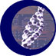
NCICB

NCI Protégé/Worklflow 1.2.1 Software Architecture Guide

Version No: 1.2
Last Modified: 02/08/2008

Author: Robert Dionne
Team: EVS
Client: National Cancer Institute - Center for Bioinformatics,
National Institutes of Health,
US Department of Health and Human Services

Document History

Document Location
The most current version of this document is located on the EVS Collaborative Tools GForge Site:
http://gforge.nci.nih.gov/docman/view.php/174/10538/Protege%20Software%20Architecture%20Document.doc

Revision History
Version Number | Revision Date | Author | Summary of Changes
1.0 | 12/24/2007 | Bob Dionne | Initial Draft
1.1 | 1/2/2008 | Sherri de Coronado | revised
1.2 | 1/15/2008 | Bob Dionne | Second draft

Review
Name | Team/Role | Version | Date Reviewed | Reviewer Comments
Frank Hartel | Product Manager | 1.0
Charles Griffin | EVS Manager
Gilberto Fragoso | Technical Manager
Sherri de Coronado | Scientist
Johnita Beasley | EVS Architect | 1.2 | 02/11/2008 | Noted as tracked changes throughout the document
Sherri de Coronado | Scientist | 1.2 | 02/15/2008 | Review accepted changes, fix links, regen toc

Related Documents
More information can be found in the following related documents:

Document Name
NCI Protege Workflow Scope Document
NCI Protege workflow Project/Task Plan
NCI Semantic Media Wiki Scope Document
BiomedGT Semntic Media Wiki
Protege Project Site
Java Wiki Bot Framework
Protege Workflow Javadoc

Table of Contents
Document History 2
Document Location 2
Revision History 2
Review 2
Related Documents 2
Table of Contents 3
Table of Figures 4
1. Introduction 5
1.1 Purpose of this Document 5
1.2 Methodologies, Tools and Techniques 5
1.3 Key Stakeholders 5
1.4 Points of Contact 5
2. Technical Overview 7
2.1 Background Information 7
2.1.1 Workflow 7
2.1.2 Integration with BiomedGT Wiki 7
2.1.3 Maintenance Efforts 8
2.1.4 Risks 8
2.1.5 Assumptions 9
2.1.6 Dependencies 9
3. System Architecture 10
3.1 Architectural Goals 10
3.2 Architectural Tiers 10
4. Software Internals 13
4.1 Workflow Plug-in Tab 13
4.2 Workflow Panel 14
4.3 Workflow Object Layer 14
4.4 Semantic Wiki Integration 15
Deployment 16
Deployment Diagram 17
Deployment Products and Framework Versions 17
Appendix 1 – Sample RDF from Wiki 19

Table of Figures

Figure 1: Data Flow Between the BioMedGT WIKI and Protégé 8
Figure 2 – Protégé and Wiki 11
Figure 3 – Workflow Object Layer 12
Figure 4 – Workflow Assignment Table 13
Figure 5 – Workflow Editing Panel 14
Figure 6 – Protégé to SMW Communication 15
Figure 7 – Sample RDF from Wiki 19

- Introduction

NCICB currently uses a customized version of Protégé, a terminology development environment, for its content development efforts. Protégé provides a mature plug-in architecture that enables customization of both GUI widget components as well as server side processes. The NCI Edit Tab, built by the NCICB/EVS Development team, provides an advanced editing environment which allows for more complex editing of OWL classes than that of the standard OWL plug-ins. This includes splitting and merging, retiring classes, advanced searching and batch edit capabilities. These capabilities are required to support the rather complex and dynamic terminology needs of cancer research communities.

To briefly summarize, the main goals of the 1.2.1 release of this project are:

- Consolidation and re-factoring of the existing code base to bring it in compliance with more recent Java technologies and best practices.

- To position it for eventual migration to Protégé 4.0

- To introduce the beginnings of the workflow capability.

1.1 Purpose of this Document
The main purpose of this document is to provide a high level design and architectural description of the new workflow capabilities in the 1.2.1 release as well as the communication between the BiomedGT Semantic Media WIKI (SMW) and the Protégé workflow environment.

1.2 Methodologies, Tools and Techniques
This development tasks are being done in Java primarily using Eclipse as the Integrated Development Environment (IDE). Ant is used for daily building of the code, unit testing, and Javadoc generation. The project artifacts are being tracked in GForge. Tracking numbers from GForge are used in the SVN logs.

1.3 Key Stakeholders
Name | Description | Responsibilities
Avinash Shanbhag | NCICB Application Infrastructure | Oversees NCICB caCORE Software Engineering
Frank Hartel | EVS Product Manager | Directs EVS Projects
Sherri De Coronado | Project Manager | Management, Technical Direction and Implementation

1.4 Points of Contact
- Project Oversight/Management
Name: Sherri De Coronado
Title: NCICB/EVS Project Manager
Email: decorons@mail.nih.gov
Phone: 925.377.5959

- Technical Overview

2.1 Background Information
As mentioned above, NCI has added several customizations to Protégé in order to support the complex, dynamic, and challenging nature of developing terminology to support cancer research communities. Fortunately Protégé enables this via a mature and well-architected plug-in interface. This interface allows for customization of UI widgets, server-side backend processes, and configuration and access control through APIs that allow programmatic access to metaprojects.

In Protégé a metaproject is just another project that can be opened as a file. It contains meta-level information about other projects, indicating which users can perform which operations, identifies connection information for the database, and so forth. It very similar to the manner in which a relational database schema is stored in system tables. This enables projects in Protégé to be configured using the Protégé tool itself.

The 1.2.1 version of Protégé will introduce two new components to this system which are described in the following sections.

2.1.1 Workflow
The Workflow component is being implemented to provide an automated means of assigning units of work to the NCI Terminology experts. Workflow is the traditional notion centered on assignments. There are two classes of users, modelers and managers. Managers create assignments, units of work, typically the editing of a specific OWL class, to modelers. The assignments are tracked as they move through a few states and when completed are marked for review by the managers. Modelers and managers both can add notes to the assignments while they are working on them. When completed, they are marked as such and deleted. A key feature of the workflow component is that assignments can be created based on proposal from the Persistence tier of the BiomedGT WIKI.
 | The archive policy is still a work in progress so currently deleting really archives to the filesystem so as to not lose any data.

2.1.2 Integration with BiomedGT Wiki
The BiomedGT WIKI opens up terminology development to the web. Internet users can use the WIKI to collaborate on OWL classes, the process culminating in structured proposals for changes to classes. These proposals are imported into the Protégé environment in the form of workflow assignments. The internal NCI domain experts can then review these proposals and possibly edit the terminology based on them. Publication of the new OWL class(es) completes the cycle and makes the new content available to the WIKI for further collaboration. Figure 1 presents a data flow diagram for this process.

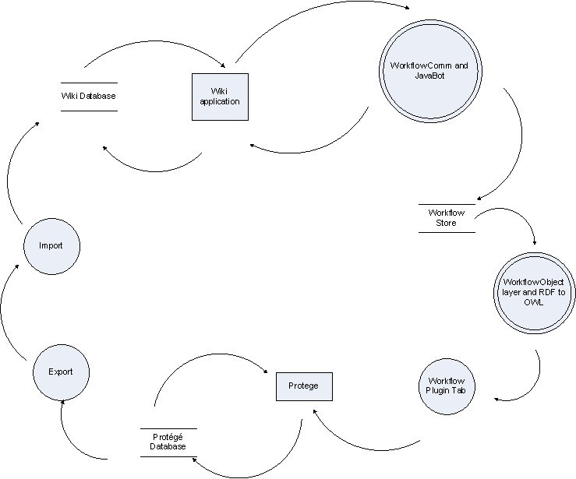
Figure 1: Data Flow Between the BioMedGT WIKI and Protégé

2.1.3 Maintenance Efforts
Concurrently with the Workflow and WIKI Integration efforts is an ongoing maintenance effort of the existing code in order to make it more amenable to change and to position the code for an eventual migration to Protégé 4.0. We are currently working against Protégé v3.2 customized for NCI, though it is planned to merge this branch back into the trunk on for the 1.3.x releases. Although this code is currently in production use on a daily basis there is a substantial list of bugs that need to be addressed. Most have workarounds and many are only usability issues but the ability to address them in a timely fashion is impaired by the current state of the code. Thus all the new development work not only must adhere to best practices but must take into account the needs of re-factoring the current code and integrating the new components in such a way as to not make matters worse.
Most of the issues reflect the age of the code, the need to deal with resource turnover on the project, churn in the robustness and quality of underlying stack, large numbers of expedient solutions chosen over time, and so forth. In other words all the usual project issues.
NOTE

2.1.4 Risks
2.1.4.1 Code Complexity
As mentioned above the quality and complexity of the existing code base is a risk. This is clearly the highest, though this situation is improving daily. There are now two resources with considerable knowledge of the code base. A conservative estimate is that well over 30% of the code has been removed and/or reworked, with no loss of function and new features added, over the previous releases. We are now at the point where major redesigns of some of the pieces are possible and necessary for the successful integration of new code. Key goals are to have the GUI widgets implement the Model View Controller (MVC) approach of Swing, and to fully encapsulate the data interaction with Protégé knowledge bases in a central location. This latter goal is essential to migrating the code to the new Protégé 4.0 OWL APIs.

2.1.4.2 Stable communication protocol with WIKI.
This has been largely worked out through a few prototypes and with the alpha release of BiomedGT is fairly stable. The current plan is to address the WIKI side of communications in wiki alpha 2 and hopefully that will coincide with the next release of workflow, which will address the Protégé side.

2.1.4.3 Testing
We are using junit tests as much as possible for all new work involving data and object layers, and wherever possible we are using them on the existing code. Over time a rigorous regression test suite will help with QA, though it will not replace the end user and usability testing, for which we will have to depend on our modelers and product experts. The design is loosely coupled and the communication is provided in a separate layer that hides the details from the rest of Workflow. This will minimize the impact when and as the WIKI needs to change to accommodate its use in production. However the lack of complete unit test coverage is listed as a risk due to the large amount of re-factoring that is being done to accommodate the new work.

2.1.5 Assumptions
We have added no new architectural components to the current system. The assumption here is that the current software is quite complex, arguably too much so, and therefore it’s prudent to work with what’s currently in place. Towards that end we’ve defined a workflow capability for this first release that’s minimal and is being built bottoms up. Such an approach will hopefully enable incorporation of early feedback from the users into iterations, adding a few features at a time.

2.1.6 Dependencies
The 1.2.1 release is dependent on some minor changes in the API to the metaproject facilities of Protégé, which have been completed. We are also using a small third party open source project for communication with the WIKI. This is a light layer on top of the Apache HTTPClient work, called Java Media WIKI Bot. This is a small layer wrapping the Apache commons HTTP client code, which is already used in Protégé elsewhere. This code is not fully documented, but it provides a ready way to access Semantic Media WIKI pages as RDF streams while the details of this communication layer are evolving.
- System Architecture

3.1 Architectural Goals
A key goal was to not introduce any new architectural elements. The only new piece is the communication between Protégé and the WIKI. In the 1.2 release we removed the codegen server, a separate server based on XML/RPC for generating new codes. This has been replaced with a Protégé server-side plug-in, thereby removing a point of failure.

Another goal is to keep the workflow component orthogonal to its use in Protégé. The actual unit of work in each assignment is treated by workflow as just a string or object. It’s largely unaware that this object is an RDF packet that can be parsed into an OWL class for editing in Protégé. This goal is just the normal separation of concerns that enable code reuse and make for easier maintenance.

The final architectural goal was flexibility in support of future usage variations. As the persistence needs of workflow are modest in terms of scalability and support for concurrent access, the storage layer is based on the file system. A key idea is that each user has a directory that contains all her assignments as XML files. The API to this layer is close to a REST style. The motivation for this is that we might envision other simpler applications like reporting that could run in a web browser and access the workflow store directly outside of Protégé.

3.2 Architectural Tiers
Figure 2 shows the high level architecture for Protégé communication with the Semantic Media WIKI. Protégé and the BiomedGT WIKI have separate databases. Communication between the two is via RDF packets over HTTP. The WIKI enables any page to be exported as RDF, so it’s simply a matter of making an HTTP connection to the WIKI with a URL that specifies the appropriate page. A snippet of what a typical RDF packet will look like is provided in Appendix I of this document. The key thing to note is that it contains structured information about OWL classes that exist in both systems.

How the structured proposals are packaged on the WIKI is documented in the Protégé component that communicates with the WIKI as well as on the WIKI itself in the section called “Data Flows”. Packages are pulled from the WIKI, processed in Protégé, and then a post is made back to the WIKI to update the status. This allows WIKI collaborators to see that the proposals are now in process in Protégé. Depending on feedback from users this protocol will evolve.

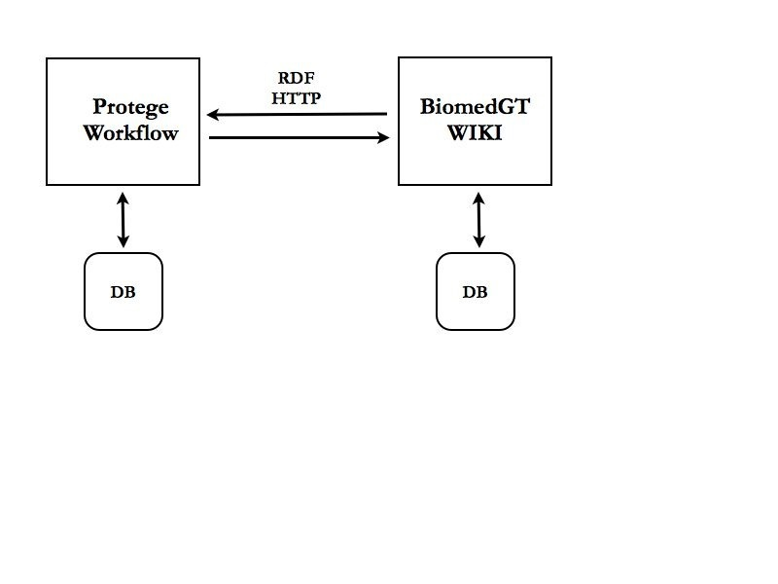
Figure 2 – Protégé and Wiki Communication

The Protégé environment is actually a client/server design that uses RMI for its communication to the server. This supports a concurrent environment for multiple modelers to edit the same database. Because of the nature of this modeling, specifically its use of description logic; the entire knowledge base is locked for each edit. In practice this still provides reasonable performance, as the transaction lengths are fairly short. In the 1.2.1 release we leverage this existing RMI-based middle tier to provide client server access to the workflow store, which is kept on the server side. Figure 3 presents a more detailed view of the object layer in the new workflow component

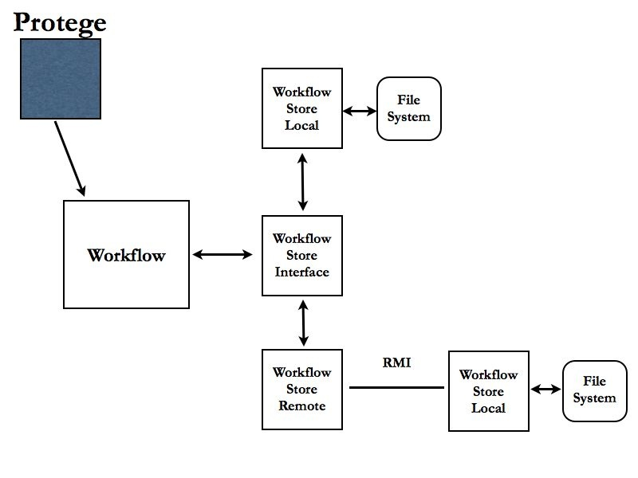
Figure 3 – Workflow Object Layer

Notice that the workflow store is specified as an interface that allows the main workflow object to ignore details of the implementations. Notice also that the workflow store local is the same in both remote and local cases. Workflow store remote simply wraps the local version in a lightweight Protege remote job object that then executes it on the server. This approach allows us to test the storage mechanism locally before remoting it, a common best practice. This approach might also make distributed workflow easier should the requirement for disconnected modeling ever emerge.

- Software Internals

As mentioned above, the Workflow capabilities introduced in the 1.2.1 release completely leverage the existing infrastructure that exists in Protege, with the exception of the component that communicates with the WIKI. There are three major pieces:

4.1 Workflow Plug-in Tab

This is the main GUI component of workflow. Implemented as a Protege plug-in, it presents an excel-style table of the assignments. Each row in the table is an assignment. The columns contain fields like the date it was created and last updates, the manager who created the assignment and the modeler it was assigned to. When a Protege user logs in, her role as either manager or modeler determines the features enabled or not in the Workflow plug-in. For example only managers can create new assignments or add new users.

Figure 4 – Workflow Assignment Table
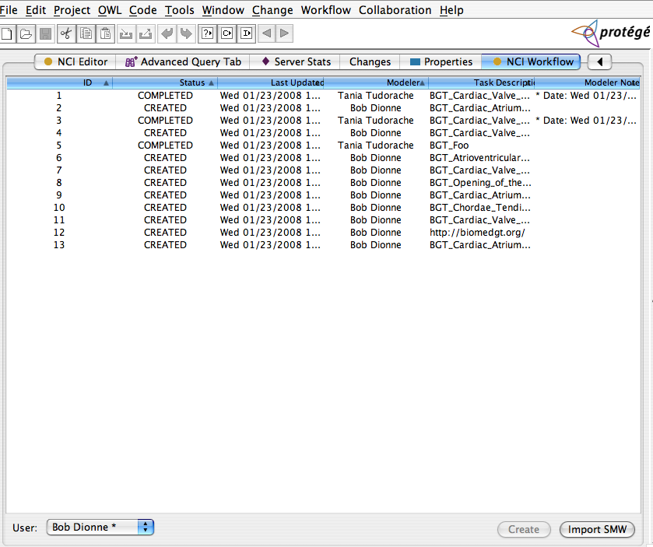

4.2 Workflow Panel
When a modeler or manager edits an assignment, the RDF packet stored in the assignment is parsed, an OWL class is created and a workflow edit panel is brought up that allows editing of the assignment. This panel is largely the same look and feel as the existing clone panel. It presents two tree panels, the top with the proposed concept and the bottom with the existing concept. Based on the proposal, the editor makes changes to the existing concept and saves it.

Figure 5 – Workflow Editing Panel
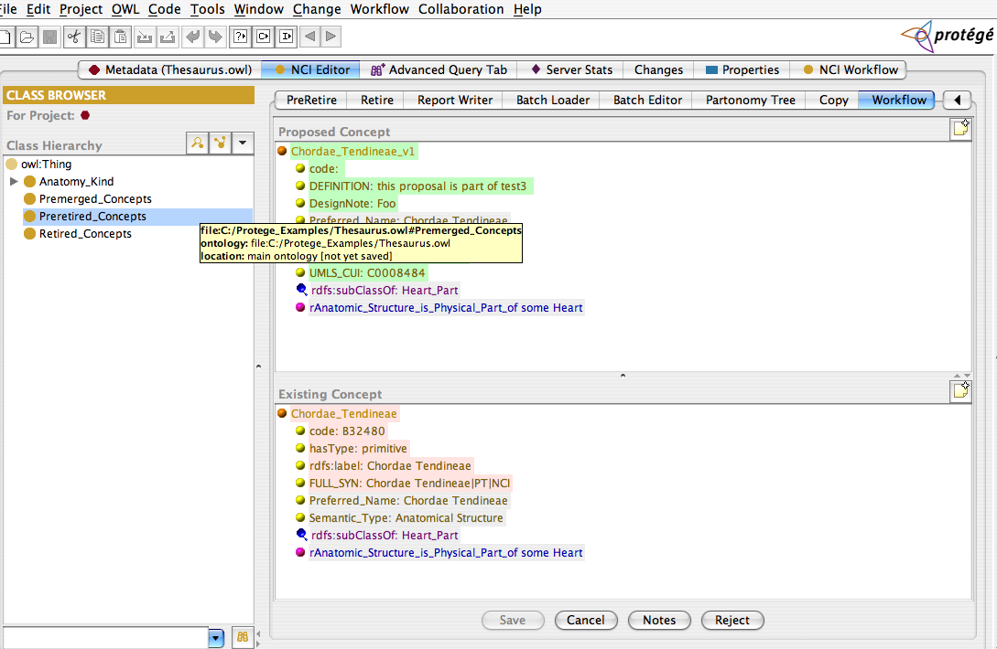

4.3 Workflow Object Layer

This object layer provides API access to the workflow store (figure 3 above). There are objects like Assignment and User that are managed by a Workflow object. A listener capability enables support for the Workflow plug-in to listen for events when assignments are updated or new ones created. This layer interacts with the server using Protege’s ProtegeJob object, which provides an architected access to the RMI services. The semantics of the ProtegeJob object are simple enough that a simple wrapper enables the storage layer code to be tested locally first before remoting it to the server. In the future if the need arises for a distributed model that involves local persistence we will be able to readily rework the code to support that.

4.4 Semantic Wiki Integration

This component is actually two distinct and orthogonal packages. The first handles communication with the WIKI. It’s responsible for establishing the connection to the WIKI and retrieving RDF from the pages. It’s built using the Java WIKI Bot Framework, an open source product which provides a layer on top of the Apache HTTPClient project. This is a small amount of code and not very well written and/or documented but it enabled us to get something up and running in order to work out this communication. This will be either cleaned up or replace with a more rigorous use of HTTP Client.

The second component handles parsing the RDF into OWL classes for use in Protégé. Some of the names use by the WIKI need to be mapped to different names in Protege, some of the classes are new and need codes, and so forth. As this layer is driven by users editing assignments in the Workflow plug-in, it caches the processing of the RDF for better performance. Figure 6 provides a high level view of these classes.

Figure 6 – Protégé to SMW Communication
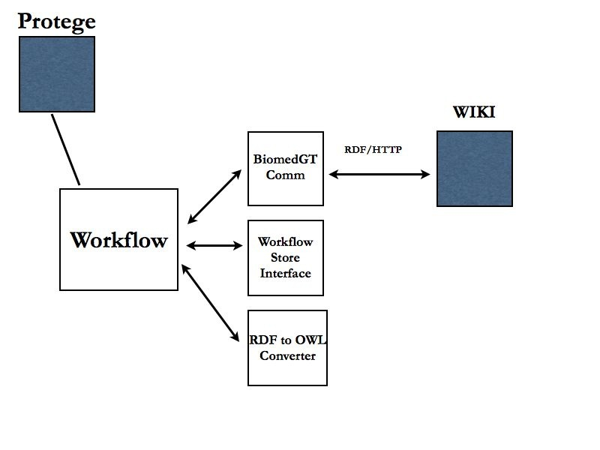

Deployment

Generally this release uses the existing build and packaging scripts of Protege. Our NCI Protege project has a master build script that is responsible for building both the client and server components. The result is a client side install package that is published in GForge for users to download. The server side is somewhat more complicated. The basic idea is that each plug-in is built as a jar file that is installed in a dedicated place that Protege uses to load them at initialization. Protege also makes use of a metaproject file that is used for access control and to store information about specific projects. This can edited as a file project in Protégé, which allows for easy maintenance.

Depending on whether or not a new database of content is being creating, the server install might run a target that configures a new project and builds the database, or it might just copy existing metaproject files over to a new location to use with an existing database. The master Ant build script also produces the needed shell scripts to start the servers.

The workflow store can initialize itself from scratch, but once a working store is in use, it will need to be backed up and maintained similar to the database. As workflow evolves we imagine some sort of archiving will be necessary to deal with older assignments.

Component Name | Third Party Jar
XML Pull Parser | xpp3-1.1.4.c.jar
Java Media WIKI Bot | jwbf-1200rc3.jar

Suggested arrangement for this section…..

Deployment Diagram
NCI BioPortal will deploy using Ant. A customizable Ant script will be created which will allow for the application to be built and deployed to the NCICB QA, STAGING and PRODUCTION Servers.

- bioportal.jar – All general NCI BioPortal application logic non-specific to an business tier is contained in the app jar.
- bioportal.war – Contains the NCI BioPortal web application-specific components and web server classes.
- third party jars – All third-party jars used by the application.
- 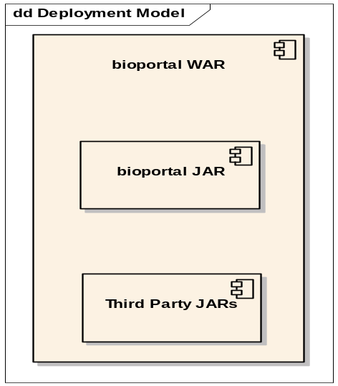

Deployment Products and Framework Versions
NCI BioPortal implements the following APIs and versions. As new versions are released or are supported by NCICB, the products will be updated after a determination that the versions do not cause problems in the application.

Name | Version | Provider | Description
Java SDK | 1.5.x | Sun Microsystems | JDK that the application runs. Deployed version dependent on NCICB standard at time of deployment. (java.sun.com/j2se/1.5/index.html)
Ant | 1.6.2 |  | The Build Scripting Tool.
JBoss | 4.0.4 | JBoss Group open source | J2EE application server. (www.jboss.org)
Tomcat | 5.1.28 | Apache open source | J2EE web container that ships integrated with JBoss. (jakarta.apache.org/tomcat)
JSF (MyFaces) | 1.1 | Apache open source | Web application framework (myfaces.apache.org/)
Commons | various | Apache open source | Common utilities required by JSF and utilized by NCI BioPortal. Includes: beanutils, collections, digester, logging
JDBC |  | MySQL | All Java driver for MySQL database
Log4J | 1.2.7 | Apache open source | Logging API. Also used by JBoss

Appendix 1 – Sample RDF from Wiki

Figure 7 – Sample RDF from Wiki


